Governor’s Snowmobile Advisory Council Meeting Minutes
August 10th, 2019 ~ LRC Room 413, Capitol Building, Pierre

Chairman Gary Ulmer called the meeting to order at 9:00 a.m. Council members Scott Erstad, Bruce Hintz, Al Nagel, Dave Kennedy, and Todd Wilkinson were present. Todd Sprang was absent.

Game, Fish, and Parks (GFP) members present were Shannon Percy and Ryan Raynor. Scott Simpson was absent.

Agenda Adoption
A motion was made by Nagel and seconded by Hintz to adopt the agenda. Motion Carried.

Approval of Minutes
A motion was made by Nagel and seconded by Kennedy to approve the minutes of the May 11th, 2019, meeting as presented. Motion Carried.

Council Appointment
Raynor recognized Todd Sprang as the newest member of the Snowmobile Advisory Council appointed by Governor Noem. Russ Johnson was not reappointed and Raynor thanked Russ for his contributions and years of service on the council. Council members serve three-year terms with no limit on the number of terms.

Director of Parks and Recreation
Unfortunately new parks director Scott Simpson had a previous engagement which he had to attend so he was unable to make this meeting. Raynor mentioned he’s already got the state convention on his schedule to attend that meeting and get to know the council members more afterwards.

Black Hills Update
Percy ran through a list of trail reroutes, some of which included maps. Reroutes included:

5T – This trail was closed early in the season last year due to an old mine shaft collapsing creating a large sink hole. Percy has been working with Warf resources to fill that in and we anticipate the trail to be put back in place for this season.

Kashmitters – A small section of Trail 5 up by Deer Mountain is being moved as Kashmitters open up more property to development.

Trailshead lodge and backdoor parking lot – Percy worked out an agreement where a new Double Vault toilet will be placed at the Trailshead parking lot. The expansion of the back door parking lot is on hold in the meantime.

Big Hill Trail 1 – Percy mentioned this was a reroute put in place about 3 years ago and they will be putting the trail back onto the original route.

Trail 1 and 3A – This junction is located on the northern part of the trail system. A small section of this area will be used as a haul route for loggers. Percy isn’t sure how many years this will last.

Turkey Tail – Trail 1, south of Big Hill is a reroute that is going back to its original location.

Trail 8 – This trail was moved last year due to winter logging which was necessary as a protected plant is located in this area. The Black Hills National Forest Service (BHNFS) requires a foot of snow before logging can take place. Unfortunately they didn’t get this done last year so the trail is staying in its current location. Percy did say he plans on changing this trail two years from now to a better snow route.

Trail 5 – This section of trail on Hwy 85 before it drops down to Cheyenne Crossing is being obliterated due to the DOT project which is straightening out the curve in the highway. The new trail will be placed right above the cut and DOT is going to pay for this reroute.

Nagel asked about the trail on Hwy #385. Percy stated it is currently on a hold until DOT finalizes a plan on this area.

Fat Tire Bike Meeting
Percy reminded the council that GFP and the BHNFS staff tried to line up a meeting in Pierre the day before this meeting with various members of the Fat Tire Bike community. Representatives of the Fat Tire Bike groups refused to meet with snowmobilers as they felt it was a Forest Service decision anyways. The decision is supposed to be made sometime this fall, which will determine if non-motorized wheeled vehicles will be allowed on the snowmobile trail system.

East River Update
Raynor indicated groomer inspections were conducted in early August with most equipment being in good shape. It was determined that the groomer from Huron will be surplused this fall and a 2015 Sno-Cat with 18,375 miles and 2,455 hours from the Black Hills will replace it. The 2008 Sno-Cat with 4,300 hours and 26,871 miles will be surplused on the Purple Wave Auction website.

Raynor mentioned the oldest groomer in the fleet is a 2006 in Redfield and a 2007 in Miller. Both machines looked to be in good working order.

Percy reminded the council that GFP was still in the process of switching dealers from Track Inc. based out of MN, WI and VT to the manufacturer based out of Medford Oregon.

2019-2020 GIA Applications
Grant-in-Aid (GIA) applications totaling $316,563 and includes 1,431 miles of groomed trail were recommended to the council: The slide below was presented to the council which included all 15 grant applications from snowmobile clubs across eastern SD. Raynor mentioned the only changes based on what was presented in May was from the De Smet club. This application changed due to De Smet dropping more miles due to the changes they say the Sioux Falls club make, back in May.

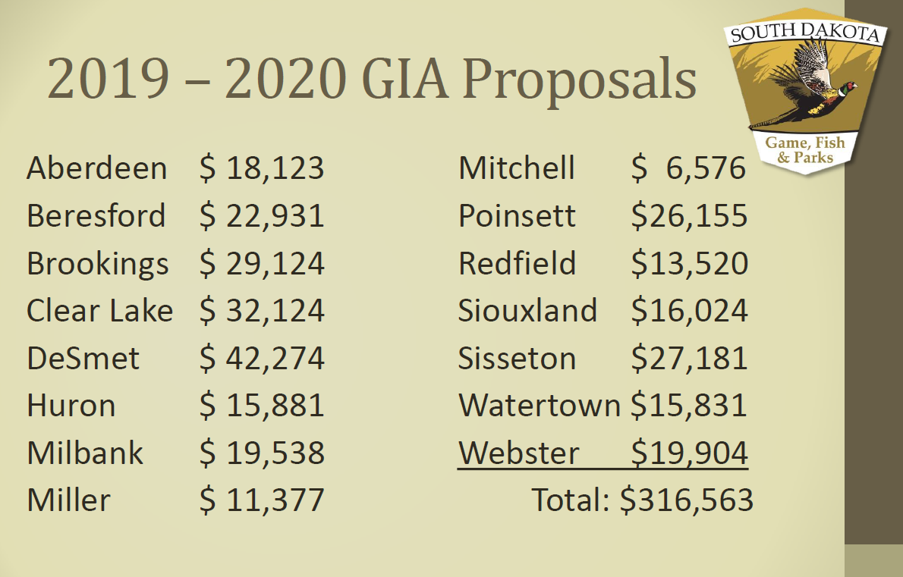

Ulmer asked if RTP for this season was available. Raynor mentioned it will be presented later in the power point when they review the budget. Wilkinson asked who was the snowmobile representative on the RTP committee? Raynor mentioned he couldn’t think of the name, but knows individual board members represent specific groups of recreation. Wilkinson asked Raynor to send the council an email of the board members and what they represent. Raynor said no problem.

Raynor mentioned with all the standing water in eastern SD, trail closures will have to take place on a trail section on highway 81 near Poinsett. Other closures may come about as summer and fall progress. Raynor said he will have to work with the individual clubs to make sure trails that need to stay closed for the entire year, will not make the map.

Wilkinson made a motion to approve the 2019-2020 GIA packages, seconded by
Nagel. Motion Carried.

FY 2019 Budget Review (July 1, 2018 to June 30, 2019)
The snowmobile program spent $939,936 during FY19 and revenue earned totaled $857,730. The snowmobile trails fund dropped from $849,257 to $767,051 as of June 30th, 2019.

Total Revenue Earned in FY19 Included:
Gas Tax: $382,935 (10,941 Registered Snowmobiles)
$10 Snowmobile License: $109,271
3% Registration Tax: $282,313
$40 5-Day Temporary Permit: $ 17,480
Interest: $ 13,249
Charges for Sales/Services: $ 33,300
Other: $ 19,182

Total Expenditures in FY19 Included:
Salaries & Benefits: $258,918 Travel: $ 11,782
Contractual Services: $121,187 Supplies & Materials: $237,844
Grants: $179,518 Capital Assets: $130,687

Capital Assets Purchased:
Raynor shared with the council the slide below to remind them what was purchased under capital assets and what RTP dollars were spent.
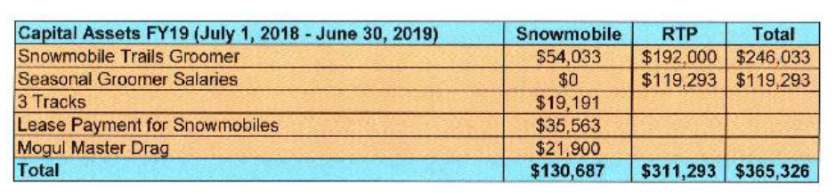

Raynor reminded the council since all the RTP authority wasn’t spent last season, $19,767 in authority would be spent this fall to use up the total grant allocation. RTP authority covers 2 years. Wilkinson asked GFP if more RTP monies were going to be requested for seasonal groomer salaries. Raynor stated those dollars were already allocated and he will be sharing that information when they review the FY20 budget.

Wilkinson asked GFP to provide a slide which shows how all RTP dollars were allocated during the RTP Advisory Council Meeting, typically held in early June. Raynor stated once the information is public, he would be able to share that information but typically, the information isn’t public until after this meeting from year to year. Raynor stated he will provide that information to the council every year, after it’s made public.

FY 2020 Budget Preview (July 1, 2019 to June 30, 2020)
Projected revenue for FY20 is $880,805 while $1,376,225 of spending authority is budgeted. The 11,623 snowmobile registrations account for $406,805 received through the gas tax reimbursement. This revenue is based on the number of registered snowmobiles as of July 1st, x .28 cents in gas tax, x 125 gallons of fuel.

Projected Revenue:
Gas Tax: $406,805
$10 Snowmobile License: $113,000
4% Registration Tax: $282,000
$40 5-Day Temporary Permit: $ 17,000
Interest : $ 12,000
Charges for Sales/Services: $ 15,000
Other: $ 35,000

Projected Expenses:
Personnel Services: $416,745 Supplies: $184,750
Travel: $ 19,550 Grants: $312,500
Contractual Supplies: $178,680 Capital Assets: $264,000

Projected Capital Assets:
Groomer: $239,000 RTP Authority for Groomer Purchase: $188,633
Drag (1): $ 25,000 RTP Authority for Drag: $0
BH DVT: $ 6,000 RTP Authority for Double Vault Toilet: $24,000

FY 2021 Budget Recommendation (July 1, 2020 to June 30, 2021)
Projected revenue for FY21 is $880,805. Raynor told the council that all revenue projections from FY20 were brought over to FY21. Specific categories are mentioned below.

Projected Revenue:
Gas Tax: $406,805
$10 Snowmobile Licenses: $113,000
3% Registration Tax: $282,000
$40 5-Day Temporary Permit: $ 17,000
Interest : $ 12,000
Charges for Sales/Services: $ 15,000

Projected Expenditures:
Personnel Services: $416,745 Supplies and Materials: $184,750
Travel: $ 19,550 Grants: $312,500
Contractual Supplies: $178,680 Capital Assets: $269,000

Projected Capital Assets:
Trails Groomer $244,000
Drags (1) $ 25,000

Wilkinson made a motion to approve the FY2021 Snowmobile budget as proposed by Raynor. Motion was seconded by Erstad. Motion Carried.

Raynor shared the following slides with the council which depicted the number of registered sleds and gas tax monies brought in over the last ten years.

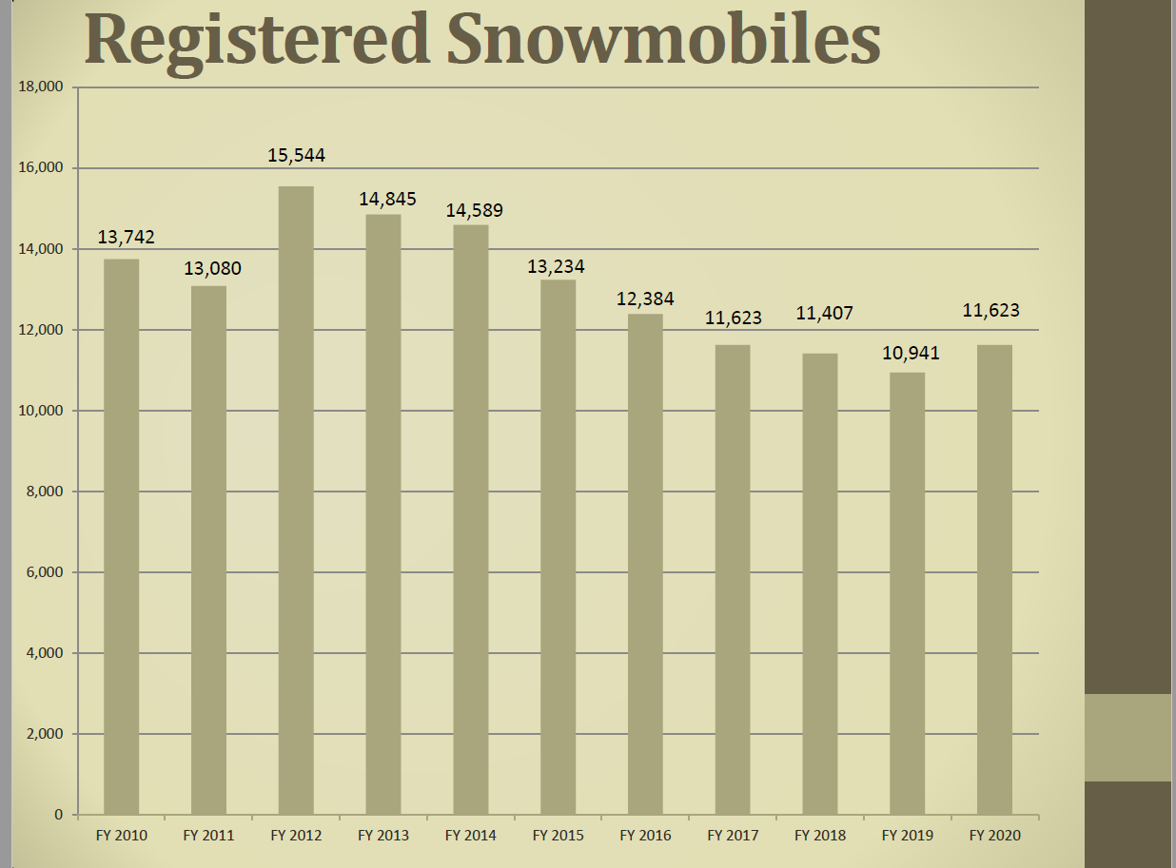

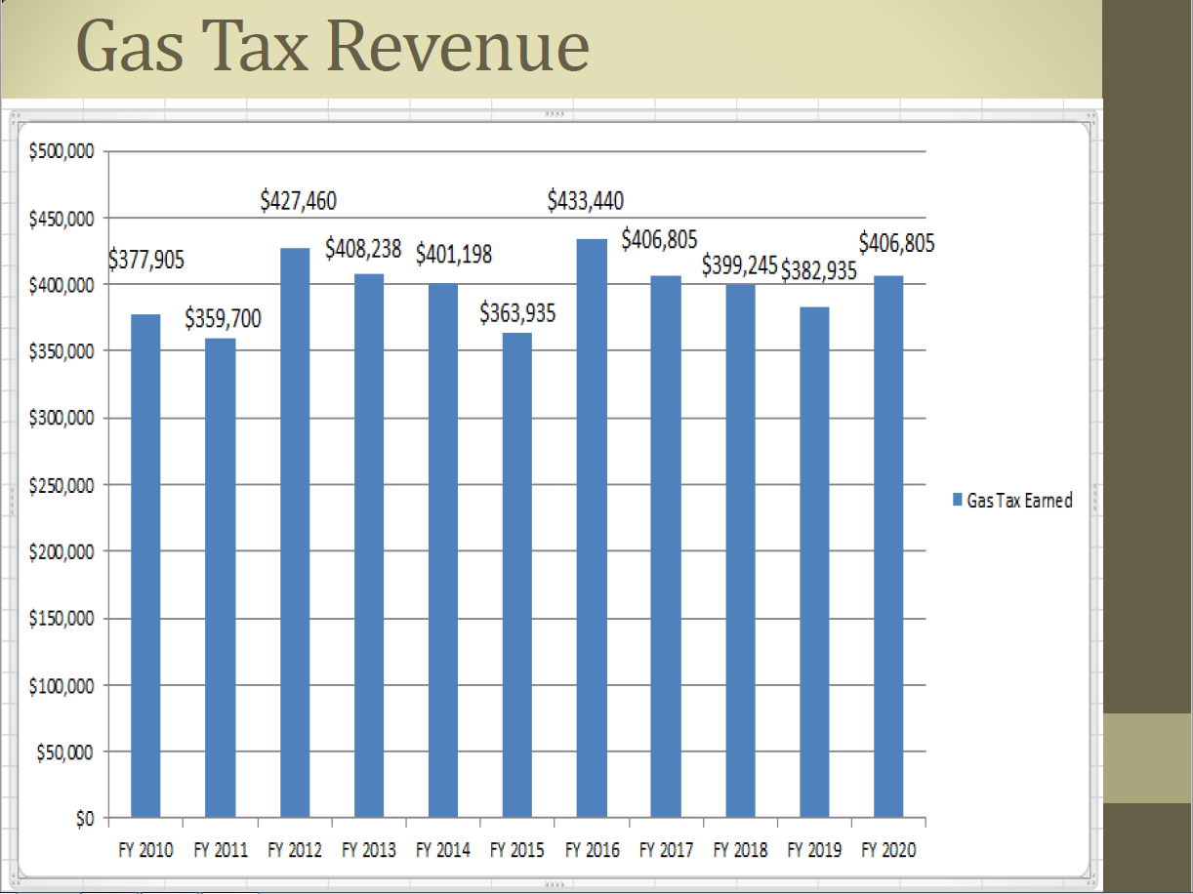

Economic Impact Study
Raynor stated this topic was to bring attention to the new director the request from the council to perform another economic impact study. While Simpson wasn’t at the meeting, Simpson did mention that the snowmobile program would be included in the next department wide EIS. Wilkinson and other members of the council agreed with that schedule.

International Snowmobile Congress
Raynor and Percy gave a brief update on their attendance with the International Association of Snowmobile Administrators. Many states and provinces are still battling with items that have already been addressed in SD such as the conversion of motorcycles and other topics. Many states are still struggling with OHV use on snowmobile trails.

Election of Officers
Gary Ulmer was voted back into the Chairman position while Dave Kennedy stays in the Vice Chairman position. A motion was made by Wilkinson and seconded by Erstad to vote. Motion Carried.

Next Meeting
The next meeting is scheduled for 10:00 a.m. on Friday, December 6th, 2019, in Watertown. This meeting is held in conjunction with the SD Snowmobile Association Association’s Annual Convention.

Adjournment
A motion was made by Hintz and was seconded by Kennedy to adjourn at 10:42 a.m. Motion carried.

