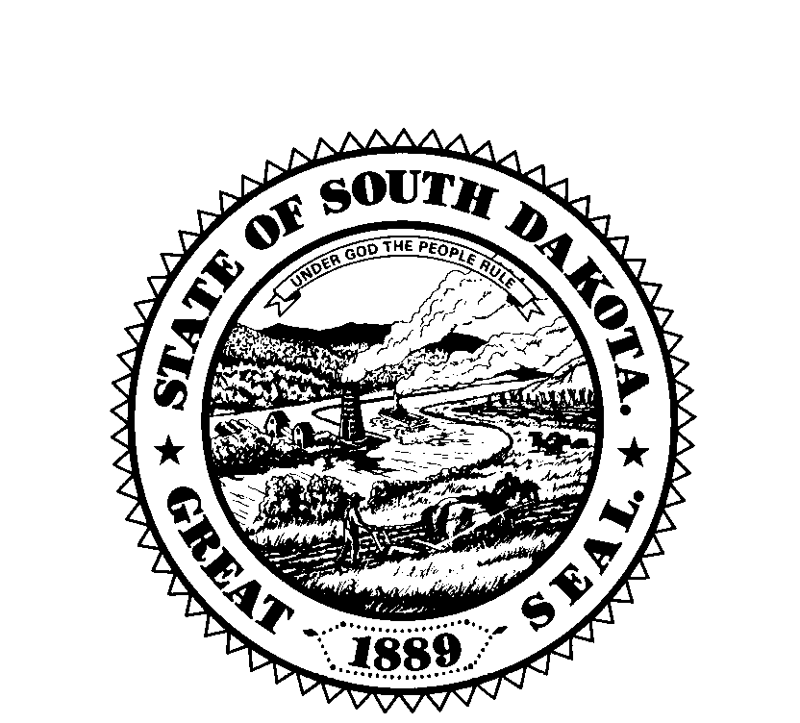
South Dakota Board of Examiners for Counselors & Marriage and Family Therapists
P.O. Box 340, 1351 N. Harrison Ave., Pierre, SD 57501-0340
Ph: 605-224-1721Fax: 1-888-425-3032

E-mail: SDBCE@midwestsolutionssd.com dss.sd.gov/licensingboards/examiners.aspx

SOUTH DAKOTA STATE BOARD OF EXAMINERS FOR COUNSELORS &
MARRIAGE AND FAMILY THERAPISTS
Friday, May 2, 2025 – 1:00 PM CDT
Best Western Plus Ramkota Hotel and Conference Center
Conference Room #1
3200 West Maple Street, Sioux Falls
or
Join Zoom Meeting
https://us02web.zoom.us/j/82569273355?pwd=PjdaJhAL3FzkC5ae2U8qTZhVzoyaFZ.1
Meeting ID: 825 6927 3355
Passcode: 028525
Call: 312 626 6799

Proposed Meeting Agenda
- Call to Order
- Approval of Agenda
- Open Forum: 5 minutes for the public to address the Board
- Approval of Board Minutes: March 7, 2025
- Approval of Financial Statement: March 31, 2025
- Executive Session (Pursuant to SDCL 1-25-2(3) for consultation with legal counsel for consideration of proposed contested cases or litigation and contract negotiations
- Old Business
  - Counseling Compact Update
  - Background Check Application Status
- New Business
  - Executive Services Contract Renewal
  - Albertsen Consulting Contract Renewal
  - Counseling Compact Data Sharing Requirements
  - Counseling Compact Data Sharing Contract
- Other Business
  - Office Update
    - 2024 Renewal CE Audits
    - Supervisor Expectations Communication
    - Board Appointments/Renewals
    - AMFTRB Meeting Delegate – September 2025
  - DSS Update
- Announcements
  - Next Scheduled Meeting – September 5, 2025 at 9:00 am CT via Zoom
- Adjourn

