Meeting Minutes
Governor’s Snowmobile Advisory Council
Saturday, May 15, 2021 ~ Pierre, SD
State Capitol Building – LRC Room 413
Zoom Link

Call to Order
Chairman Dave Kennedy called the meeting to order at 9:02 a.m.

Roll Call
Members Present: Dave Kennedy, Gary Ulmer, Al Nagel,

Members Present on Zoom: Todd Wilkinson, Todd Sprang, Scott Erstad and Bruce Hintz

Members Absent: Scott Simpson

GFP Staff Present: Ryan Raynor and Shannon Percy

Adoption of the Agenda
A motion was made by Wilkinson and seconded by Ulmer to adopt the agenda as amended. Motion Carried.

Approval of the Minutes
A motion was made by Nagel and seconded by Wilkinson to approve the minutes from the February 14, 2021 meeting. Motion Carried.

Public Comment
No comments were made during the public comment period.

2021 Legislative Session
Raynor explained that no bills went through legislative session that impacted the snowmobile program.

Black Hills Season Review
Overall, it was a great snow year in the Black Hills stated Percy. Grooming began on January 12th and ended on February 28th. During that time frame, 16,977 miles were groomed in South Dakota and 2,227 miles were groomed in Wyoming for a total of 19,204.

Percy also shared the following groomer hours which were down compared to last year.

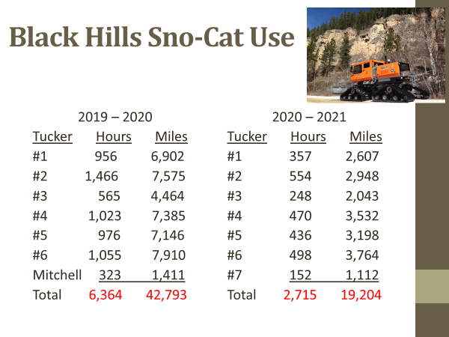

*Mitchell groomer used in the BH fleet due to issues with breakdowns during the Governor’s Ride. This cat accumulated 323 hours and 1,411 miles. These totals are included in the total row in the chart above.

Sno-Cat Downtime
Percy stated last year was the first time ever tracking the amount of time our groomers were down to due repairs. We had 360 hours of downtime throughout the various cats ran at Hardy Camp. Mostly minor items but one differential was replaced.

Percy also shared with the council of an ongoing electrical issue with Cat #7, which would transfer to East River. The groomer will just suddenly shut off and won’t share any codes to help trouble shoot. With all the issues, GFP is trying to decided whether or not Tucker has truly resolved the issues to the point where we feel confident it will run for a club in Eastern, Sd.

Black Hills Trail Counts
Percy stated not much positive news here as traffic counts were down significantly compared to last year. Below are those numbers shared with the council. Most popular trails included those trails connected to trailside vendors. He also mentioned the popular days of the week switched, where it used to be Thursday through the Saturday, this season, it switched from Friday through Sunday.

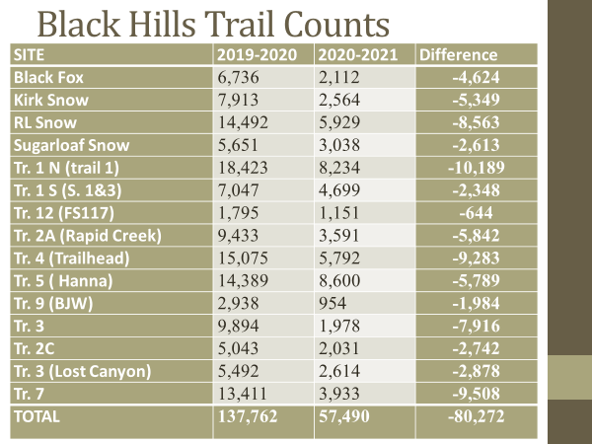

Black Hills Revenue

Percy stated almost half the revenue was generated from the Black Hills compared to last year. For the first time, we didn’t groom enough miles to full fill the full reimbursement dollars per contract with the state of WY. The number of permits sold through the Motorcycle license also was down due to lack of deep snow conditions. A full report of revenue is listed below.

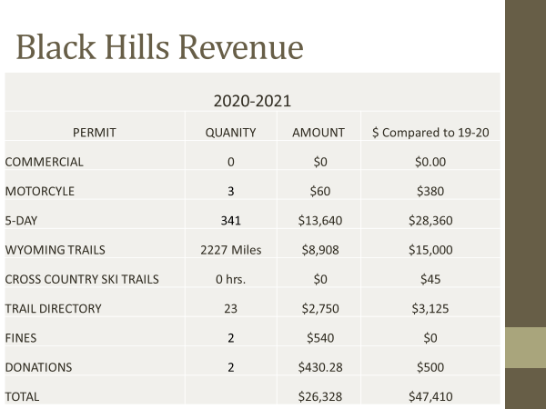

Percy shared the image below which shows what states are represented from those buying 5-Day Temporary Permits.

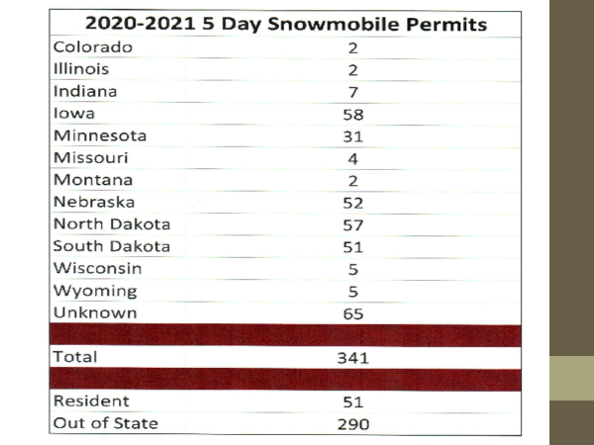

Forest Service Meeting
Percy recently had a wrap up meeting with the timber industry reviewing possible reroutes for next season. What isn’t known right now is how the mill being shutdown will impact timber cuts and timing of reroutes for the next few years.

Percy shared the following reroutes he’s working through with the Forrest Service and Timber Industry for next season.

Due to development, the county now has to plow 231 which jeopardized the trail. Percy stated, he feels confident he can get around this one.

2 other areas to the south are currently unknown how they will progress so Percy is working through the normal channels to figure out what will take place there. These trails include 2, 5 and 7.

Another reroute on Trail 7 involves working with landowners along with people wanting to purchase the private property. Fortunately, the current landowners want to make sure new owners, allow the snowmobile trail to go through or GFP finds out we easily have a reroute.

Trail 2 reroute on Williams Draw south of Deerfield is trying to move a trail off of a shared OHV trail back to 231. Current OHV use is providing challenges with the FS and providing a safe snowmobile trail.

Other reroutes including the Kaschmitter properties are due to further road development on this property to accommodate future housing. Percy hopes to get through this property so he can keep trail access to 5T recreational springs and others. This reroutes impacts a lot of people and businesses.
Spruce Timber sale impacting trail 1, 2 and trail 8 in the Hell Canyon District. Percy stated this one scared him a little due to the number of timber cuts associated with a winter removal due to a snail in the area. This is a high use great snow conditions area, but Percy stated this was retracted during the Forrest Service meeting until next year. Percy stated he will be spending a lot of time on this reroute working with the timber industry and FS office. He anticipates this being a multi-year cut once it does start.

Wilkinson asked how much active timber cutting is going on now that a mill is shutdown. Percy stated that is still unknown at this time. This sale is for going after spruce instead of pine. Wilkinson then asked if anybody is even bidding on the projects. Percy stated the Spruce Timber sale has not been let yet.

Fat Tire Bike Update
While the Fat Tire Bike community is usually represented at the wrap up meeting, they were not this time. Discussion did take place about any issues though. Percy stated due to a lack of snow, we really didn’t see much use, where use was allowed, so he felt it wasn’t a good winter to gauge our concerns of allowing FTB’s on snowmobile trails. Shannon stated a group of FTB’s have applied for access from Dumont Lot, to Steel Wheel on Trail 7. Percy mentioned this trail segment really scares him due to a narrow trail width of 8ft, plus a lot of rental businesses on the trail including Mystic Hills, Black Hills Off Road Rentals and Steel Wheel renting sleds. Plus, this trail doesn’t see a lot of snow to begin with. Percy was encouraged to bring those comments to the Advisory Board.

Wilkinson asked Shannon to remind the council what monetary contributions the Fat Tire Bike community provides the snowmobile program and sense the Forrest Supervisor has changed, is it possible to eliminate trails, instead of just adding trails. Percy stated last year they donated $500 through a go fund me page. This season no donations have come in up to this point. Shannon did try and address the 2nd question at the meeting. At this time, the timber industry is currently at the top of the New Forrest Supervisor’s list and he hasn’t had time to review the Fat Tire Bike situation.

Wilkinson asked how much it costs per mile to maintain a snowmobile trail. Percy stated it’s been awhile since he’s reviewed that information and didn’t want to throw a number out there at this time. He did agree that the $500 wouldn’t cover much at all and it was more intended as an in-kind gesture.

After further discussion, Wilkinson made a motion to not support anymore miles unless there are contributions to the existing miles allowed that equate to an adequate capacity based upon operational costs to remove any existing miles. Kennedy seconded. Motion Carried.

Rebar Attachment
Raynor stated he still wasn’t able to get an exact cost of the fabricated rebar attachment but did learn Lyndan was only comfortable allowing 6 to 10 units at first, instead of 1 per club. Raynor stated this would still work as clubs have a certain length of time to complete trail signing and when one club is done, it could be shared accordingly. Raynor expects to have these in hand before signing begins this fall.

Raynor shared with the council to run this attachment the clubs will need a heavy-duty rotary drill with large amp hour batteries. Based on a quote, Raynor asked the council to approve spending up to $21,000.

Al Nagel made a motion to approve the purchase of 14 Heavy-Duty Rotary Drills which will include 2 - 9amp hour batteries or larger, a carrying case and battery charger. Kennedy seconded. MOTION APPROVED

Camera and Website Statistics
He did not hear back from the people who gather this information before the meeting but could share it at the August meeting.

Kalkomey Safety Course
Raynor updated the council on the South Dakota Snowmobile Safety Course being managed online through Kalkomey. Raynor stated while he hoped to have worked with SDSA more throughout this process, things just kept moving forward where coordinating would have been difficult. After further discussion the system is live for anyone to take the course and Raynor will be working with the YETIS to design the wallet size card certificate mailed to participants. Raynor shared a few images of what the test takers see to the council.

Wilkinson made strong objections to paying for any percent of a course for non-residents. Other council members agreed

Raynor will also provide to the council at the August meeting, a breakdown of potential costs of the council and GFP agree to pay for all or a percent of each test taken.

Raynor also agreed to discuss with SDSA how we think it’s appropriate to provide discount codes if the council agrees to pay for a certain percent.

Signing Manual Update
Raynor stated it took a few years, but the signing manual has finally been updated and those updates had been approved by the Office of Risk Management. Raynor asked Kim Raap with Trails Work Consulting to come up and discuss the updates to the signing manual.

Kim Raap reviewed details from every page explaining the changes in detail. Improvements made to the document include but not limited to: stop sign usage, signing around hazards, signing through a four way stop, sign placement, signing in accordance with groomer operations and more. Kim also recommended we take a strong look at the trail system in Webster as a large portion of it sits on a highway that doesn’t allow much room on the road shoulder.

Raynor reminded the council that these manual updates aren’t a change in signing philosophy, but merely making sure more signing scenarios are addressed, and those scenarios that were previously addressed, are addressed in more detail to help clubs sign it right the first time around.

After further discussion, it was discussed for Kim and Ryan to provide a training opportunity at this year’s state snowmobile convention, potentially zoom type trainings with clubs along with attending club meetings once those start back up. Raynor also told the council he would provide by email the manual to the clubs, along with printed manuals which will get done before the signing season starts.

Fiscal Year 2021 Budget Review
Raynor reminded the council that figures he was about to share would be through the end of April.

Raynor shared the slides below which show the Black Hills budget, then a full program summary including the Black Hills, East River GIA Program and any other administrative costs.

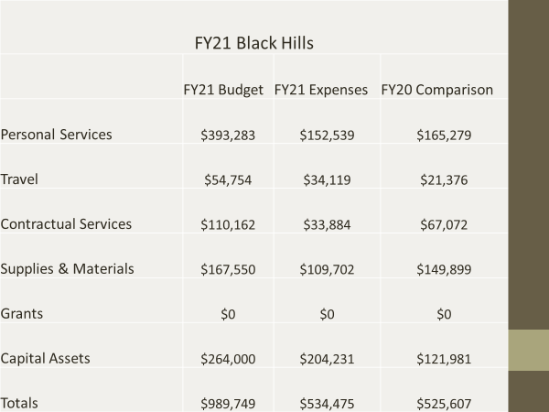

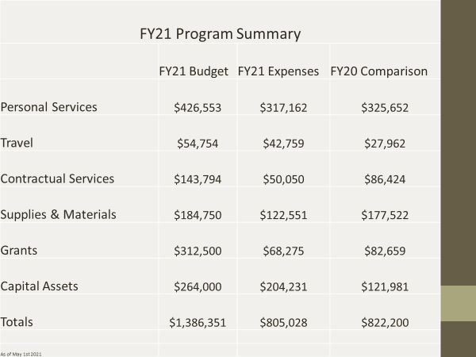

FY 21 Revenue
Raynor shared the following information for revenue generated through the month of April. Raynor stated while snow fall across the state was well below average, sled purchases was in high demand as the excise tax is as high as it’s been since FY2016.

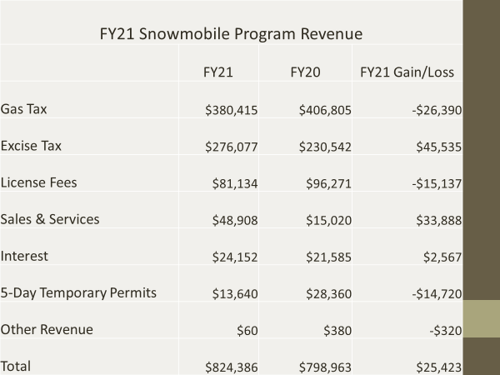

Fiscal Year 20 Grant-In-Aid
A total of $94,352 is anticipated to come out of the Grant in Aid program. Raynor reminded the council these costs are covering our fixed expenses including, signing costs, private easements, insurance, fuel, grooming, maintenance and repairs and groomer storage. Raynor stated it was a poor grooming season for clubs with the best snow conditions falling in the Brookings Clear Lake area, and 5 clubs had zero grooming hours.

The following is a breakdown of the club’s total expenses through the GIA budget.

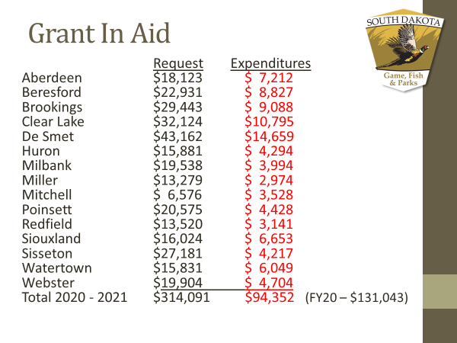

Raynor shared the following breakdown of hours put on the groomers in FY21:

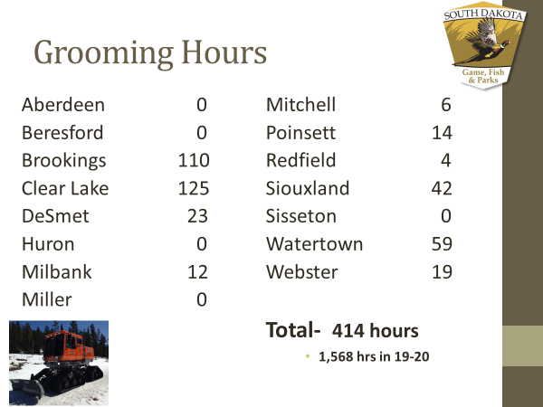

Fiscal Year 22 Grant-In-Aid Proposals
Raynor discussed the proposals received for next season including the use of 11 state-owned groomers, three privately-owned groomers, 1,003 miles of trail and 1,405 groomed miles. Total Funding request of $310,632

Most of the G.I.A. proposals are keeping their trail systems the same as the previous season. Raynor did mention he knows a couple clubs are still looking at potential reroutes and expects minor changes to the funding levels, to approve in August.

The following are the proposed trail changes for the Eastern South Dakota trail system for the 2021-2022 snowmobile seasons:

Aberdeen: No changes

Beresford: No changes

Brookings: Now grooming from Bruce to Estelline, removed a section of trail from Hwy 14, moved the connection from White to Bushnell a mile to the West. Grooming rotation includes 3 main loops which takes a couple of days to groomer through one total cycle.

Clear Lake: No changes

De Smet: Removing east side of Bryant to Hwy 81, removing 28 & 81 junction south to Poinsett, removing from Poinsett, south to north side of Arlington and made minor changes to the trail as it goes around De Smet on the South side.

Huron: Changes made to the grant to accurately reflect trail miles on the ground

Milbank: No changes

Miller: No changes

Mitchell: No changes

Poinsett: Adding signing from Poinsett to Arlington and grooming to Arlington

Redfield: No longer participating in the GIA program. Equipment will be surplused this fall as the Jessen family does not anticipate any resurgence of club participation.

Siouxland: No changes

Sisseton: No changes

Watertown: No Changes

Webster: No changes

The following chart shows the Grant-In-Aid requests for the 2020-2021 snowmobile season broken down by each expense category:

FY 2022 Grant in Aid Funding Request
Club | Fuel | Maintenance | Grooming | Signing | Lease | Insurance | Rental | Total |  | Miles | Miles Groomed
Aberdeen | $6,318 | $3,040 | $4,750 | $1,440 | $0 | $1,075 | $1,500 | $18,123 |  | 72 | 76
Beresford | $0 | $0 | $20,148 | $1,460 | $400 | $923 | $0 | $22,931 |  | 73 | 73
Brookings | $12,968 | $6,240 | $9,750 | $2,260 | $0 | $2,000 | $1,500 | $34,718 |  | 113 | 195
Clear Lake | $0 | $0 | $30,084 | $1,360 | $0 | $975 | $0 | $32,419 |  | 68 | 109
DeSmet | $0 | $0 | $42,228 | $1,540 | $0 | $1,002 | $0 | $44,770 |  | 77 | 153
Huron | $4,988 | $2,400 | $3,750 | $1,000 | $0 | $1,030 | $1,500 | $14,668 |  | 50 | 100
Milbank | $6,983 | $3,360 | $5,250 | $1,320 | $0 | $1,125 | $1,500 | $19,538 |  | 66 | 84
Miller | $4,921 | $2,368 | $3,700 | $740 | $0 | $950 | $600 | $13,279 |  | 37 | 74
Mitchell | $1,895 | $912 | $684 | $660 | $0 | $925 | $1,500 | $6,576 |  | 33 | 38
Poinsett | $9,310 | $4,480 | $7,000 | $1,440 | $0 | $940 | $1,500 | $24,670 |  | 72 | 112
Redfield | $0 | $0 | $0 | $0 | $0 | $0 | $0 | $0 |  | 0 | 0
Siouxland | $5,387 | $2,592 | $4,050 | $1,560 | $0 | $975 | $1,460 | $16,024 |  | 78 | 108
Sisseton | $10,141 | $4,880 | $7,625 | $2,060 | $0 | $975 | $1,500 | $27,181 |  | 103 | 122
Watertown | $5,054 | $2,432 | $3,800 | $1,520 | $600 | $925 | $1,500 | $15,831 |  | 76 | 76
Webster | $7,066 | $3,400 | $5,313 | $1,700 | $0 | $925 | $1,500 | $19,904 |  | 85 | 85
Totals | $75,031 | $36,104 | $148,132 | $20,060 | $1,000 | $14,745 | $15,560 | $310,632 |  | 1,003 | 1,405

Safety Report
Raynor gave a brief overview of the past years reported accidents. There were 24 accidents reported with 0 fatalities with all accidents reported in the Black Hills. 20 out of 24 accidents were on rentals.

Next Meeting
The next meeting is tentatively scheduled for Saturday, August 14th, 2021 at 9:00 a.m. with the intent of having a face to face meeting and access to a Zoom link.

A motion was made by Erstad and seconded by Wilkinson for this meeting date and time. MOTION APPROVED

Adjournment
A motion was made by Nagel and seconded by Ulmer to adjourn the meeting at 11:11 a.m. Motion Carried.

