Meeting Minutes
Governor’s Snowmobile Advisory Council
Saturday, May 11, 2019 ~ Capital Building Room 413, Pierre South Dakota

Call to Order
Chairman Gary Ulmer called the meeting to order at 9:00 a.m.

Roll Call
Members Present: Dave Kennedy, Russell Johnson, Gary Ulmer, Al Nagel, Bruce Hintz and Scott Erstad

Members Absent: Todd Wilkinson

GFP Staff Present: Ryan Raynor and Shannon Percy

Adoption of the Agenda
Erstad added East River Groomer School to the agenda.
A motion was made by Hintz and seconded by Erstad to adopt the agenda as amended. Motion Carried.

Approval of the Minutes
A motion was made by Nagel and seconded by Johnson to approve the minutes from the February 15, 2019 meeting. Motion Carried.

Public Comment
No comments were made.

New Parks and Recreation Director
Raynor shared a slide copied from the Game Fish and Parks website about Scott Simpson who was appointed as the Director of the Parks and Recreation Division. Percy and Raynor were able to sit down with Simpson to discuss the snowmobile program for over four hours. While Simpson wasn’t able to make the May meeting, he looks forward to working with the advisory council and SDSA board.

2020 Legislative Session
Percy explained the verbiage in our SD codified law which prohibits ATV’s and UTV’s from operating on a designated snowmobile trail, currently sits in the law that defines a snowmobile. For our rangers to enforce this law it needs to be in the law which defines the operation on a state snowmobile trail. As it stands, the definition of a snowmobile is broken up between two different laws and language needs to be added to 32-20A-24, so any ATV’s found on the trail could actually be sited. GFP will share more information about this change in August as we do intend to take this to the 2020 legislative session.

Governor’s Ride
Raynor explained the confusion about from the 2019 Governor’s Ride about exactly how many snowmobiles the council and GFP agreed to pay for during the event. Under Tony Schmitt, the council and GFP agreed to pay for a certain amount of sleds or percent of sleds needed for the ride. With no information found in any of the minutes, Raynor asked the council to approve a new number of sleds GFP would pay for through the snowmobile program budget. Kennedy thought the previous number was 10 sleds. Raynor mentioned we only hope the event continues to grow and if sleds from the 4 main manufacturers are not used for the event, we only rely more on rentals or personal sleds being used.

Erstad mentioned 15 snowmobiles.

A motion was made by Johnson and seconded by Nagel for 15 sleds, of any combination to be paid for out of the snowmobile trails fund. Motion Carried.

Black Hills Season Review
Overall it was a great snow year in the Black Hills stated Percy. Grooming began on December 15th and ended on March 24th. During that time frame, 33,509 miles were groomed in South Dakota and 4,943 miles were groomed in Wyoming.

Percy also shared the following groomer hours which were almost 8,000 more miles groomed than the previous year. Percy stated with all the breakdowns occurring around Governor’s Ride week, they ended up keeping the groomer to be transferred to the East River program. The new groomer came in about mid-season which is why the hours were so low. New cat #3 had 349 hours and 2,577 miles. All 7 groomers total is listed below.

Tucker | Total Hours | Total Miles
#1 | 999 | 6,715
#2 | 828 | 4,300
#3 | 844 | 5,977
#4 | 962 | 6,656
#5 | 541 | 4,514
#6 | 1,128 | 7,713
Total | 5,651 | 38,452

Black Hills Trail Counts
Percy stated trail counts were up almost 10,000 clicks. 86,711 counts were recorded in 2018 with 96,647 being recorded in 2019.

Black Hills Revenue
Revenue collected from the Black Hills to date included:
- 5-Day Temporary Permit: $21,040 (526 permits)
- State of Wyoming: $15,000 (4,942 miles groomed)
- Trail Directory: $ 3,000 (24 entries)
- Commercial Permits: $ 0
- Motorcycle Permits : $ 100 (5 permits)
- Donations: $ 240
- Cross Country Ski Trails: $ 60
- Fines $270

Total: $39,710

Percy shared a new slide which will be presented at this meeting annually breaking down what states the 5-Day Temporary Permits were sold too. Below is the breakdown.

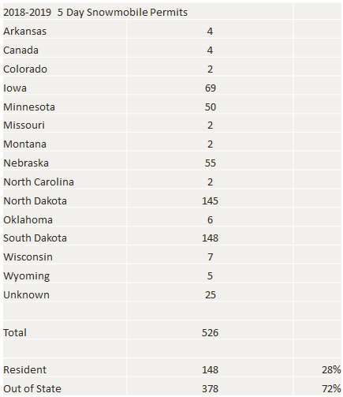

Trail Re-Routes
Percy stated that the annual meeting with the Forest Service to discuss re-routes for the 2019-2020 snowmobile season finished earlier this week. Percy stated that some reroutes are requested by the timber industry and others by him.

Percy is asking the Forest Service to approve a back door parking lot expansion with a vault toilet. The trail, which currently cuts through the back door lot, would stay in the ditch for another half mile than cut into the trees connecting to existing trails.

Trail 5T had a sinkhole open up which closed the trail for the majority of the year. Percy is working with Wharf mine to fill the hole in.

Kashmitters Trail 5, located across from Deer Mountain, will be moved as they are opening up this area for further expansion. Percy is still working with Kashmitters on a potential easement.

Percy shared a map for the Wizard Unit. While he hasn’t had a chance to visit the area, he hopes to next week. Kennedy asked the location of this unit? Percy stated it’s on trail 1, close to 3A.

Turkey Trail is a reroute from a timber cut about three years ago. GFP asked for the trail to go back to its original location which was approved.

Trail 8 was moved last year and held certain restrictions due to a flower found in the area. Timber industry could only log in the winter time with at least 18 inches of snow on the ground. Due to all the snow in the area they were unable to log in this area. Percy was told they would get it logged in 2020.

Percy and Raynor have started conversations with Tucker Sno-Cat to start purchasing groomers and dealing with the manufacturer directly, based out of Medford Oregon. Customer Service and communication have been poor over the past three years with many examples from both sides of the state. GFP is writing a letter and they will see where the conversation goes.

Fat Tire Bike Update
Percy stated the Forest Service, Fat Tire Bike representatives, and GFP met earlier this spring in Spearfish, a meeting that went much better than the previous year. They agreed to meet later this summer with 2 members from the council, two members of the SDSA board, along with 4 members of the fat tire bike community, GFP representatives and FS representatives. Black Hills National Forest Supervisor, Mark Van Every is also expected to attend. Percy will send out reminders to both snowmobile groups and work on scheduling the meeting which could occur in Pierre.

Camera and Website Statistics
Raynor shared some website statistics for the second straight year. Besides a better snow season than last year, the GFP media team felt page views were up due to pushing trail conditions through a “What’s Trending” portion of the GFP website. This most likely led to the better statistics in all categories compared to last year.

34,064 Page Views – Total number of pages viewed. Repeated views are counted.
1:04 average time on page – The average amount of time users spent viewing a specified page or screen, or set of pages or screens.
38% Bounce Rate – The percent of visits that are single-page only. (People who visit one page and leave) Usually a high bounce rate is a sign that people are leaving y our site/pages because they aren’t finding what they are looking for. 26-46% is excellent and 41-55% is average.
Map – 7,310 views with an average of 140 views a day were found in 2018. These statistics were not able to accumulate for the 2019 season.

Fiscal Year 2019 Budget Review
Raynor gave a summary report of the expenses through April 28th, 2019. Raynor reminded the council that the majority of expenses out of the Grant In Aid Program have not been submitted through fiscal yet so the report below does not share known expenses. Projected GIA expenses for the fiscal year are $175,240.

A summary is listed below which combines the budgets of the Black Hills, East River, and Administration into the Snowmobile Program Budget:

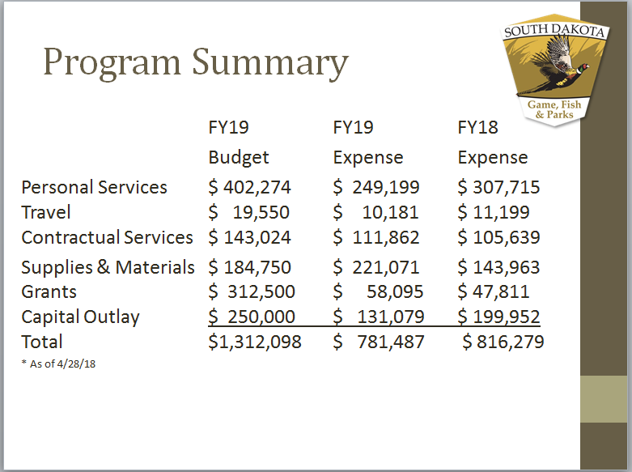

FY 19 Revenue
Raynor stated that revenue is currently down compared to last year but anticipates between $25,000 and $35,000 once the Sioux Falls Groomer goes up for auction.

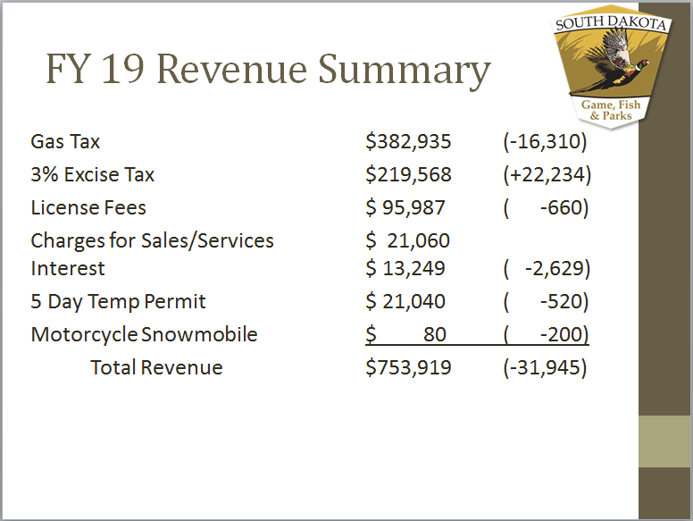

Fiscal Year 19 Grant-In-Aid
A total of $175,240 was spent to date out of the GIA budget. Raynor reminded the council these costs are covering our fixed expenses including, signing costs, private easements, insurance and storage. We anticipate the final costs out of the GIA to be close to this figure as he is still waiting on one clubs reimbursement request.

The following is a breakdown of the club’s total expenses through the GIA budget.

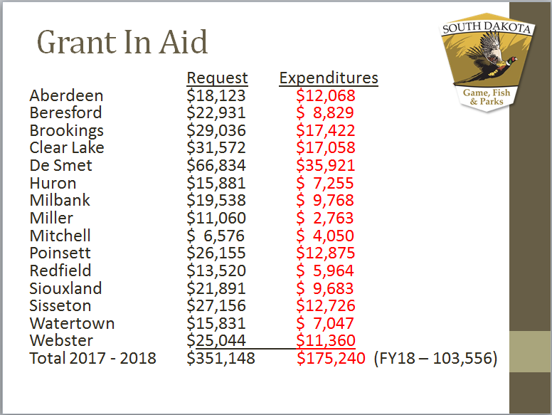

Raynor shared the following breakdown of hours put on the groomers:

Aberdeen – 154 Miller – 32
Beresford – 28 Mitchell – 24
Brookings – 243 Poinsett – 226
Clear Lake – 218 Redfield - 83
De Smet – 460 Siouxland – 142
Huron – 64 Sisseton – 203
Milbank – 199 Watertown – 83
Webster - 112

Total Grooming Hours – 2,271

Fiscal Year 19 Grant-In-Aid Proposals
Raynor discussed the proposals received for next season including the use of 12 state-owned groomers, three privately-owned groomers, 1,089 miles of trail and 1,463 groomed miles. Total Funding request of $325,715

Most of the G.I.A. proposals are keeping their trail systems the same as the previous season. The following are the proposed trail changes for the Eastern South Dakota trail system for the 2019-2020 snowmobile seasons:

Brookings: Nominal increase to reflect the removal of a trail on the eastern side of the Bushnell loop and adding a trail from White, straight through Bushnell.

Clear Lake: Grooming miles were adjusted for accuracy, which included a small increase.

De Smett: Removed 39 miles of trails including a long spur from Willow Lake to Henry, Lake Preston to Oldham, and Oldham South to the Sioux Falls trail. This will also improve grooming efficiency as the trail system grew too big to efficiently groom and removed minimally used trails.

Miller: 1 mile spur south to Ree Heights.

Siouxland: Removed a trail spur north and west of Madison due to lack of use and eliminating 3 miles around Wentworth.

Sisseton: Insurance estimate had a small increase.

Webster: Removing large spur on the north east part of the trail system to improve signing and grooming conditions along with a lack of use.

The following chart shows the Grant-In-Aid requests for the 2019-2020 snowmobile season broken down by each expense category:

Club | Fuel | Maintenance | Grooming | Signing | Lease | Insurance | Rental | Total
Aberdeen | $6,318 | $3,040 | $4,750 | $1,440 | $0 | $1,075 | $1,500 | $18,123
Beresford | $0 | $0 | $20,148 | $1,460 | $400 | $923 | $0 | $22,931
Brookings | $10,440 | $5,024 | $7,850 | $2,460 | $0 | $1,850 | $1,500 | $29,124
Clear Lake | $0 | $0 | $29,808 | $1,340 | $0 | $976 | $0 | $32,124
DeSmet | $0 | $0 | $48,024 | $2,400 | $0 | $1,002 | $0 | $51,426
Huron | $5,486 | $2,640 | $4,125 | $1,100 | $0 | $1,030 | $1,500 | $15,881
Milbank | $6,983 | $3,360 | $5,250 | $1,320 | $0 | $1,125 | $1,500 | $19,538
Miller | $4,123 | $1,984 | $3,100 | $620 | $0 | $950 | $600 | $11,377
Mitchell | $1,895 | $912 | $684 | $660 | $0 | $925 | $1,500 | $6,576
Poinsett | $9,975 | $4,800 | $7,500 | $1,440 | $0 | $940 | $1,500 | $26,155
Redfield | $4,655 | $2,240 | $3,500 | $700 | $0 | $925 | $1,500 | $13,520
Siouxland | $5,387 | $2,592 | $4,050 | $1,560 | $0 | $975 | $1,460 | $16,024
Sisseton | $10,141 | $4,880 | $7,625 | $2,060 | $0 | $975 | $1,500 | $27,181
Watertown | $5,054 | $2,432 | $3,800 | $1,520 | $600 | $925 | $1,500 | $15,831
Webster | $7,066 | $3,400 | $5,313 | $1,700 | $0 | $925 | $1,500 | $19,904
Totals | $77,523 | $37,304 | $155,527 | $21,780 | $1,000 | $15,521 | $17,060 | $325,715

Safety Report
Percy gave a brief overview of the past years reported accidents. There were 21 accidents reported with 3 fatalities (21 accidents in the Black Hills and 0 accidents reported East River.) Percy mentioned it was a difficult year as two fatalities were related to snowmobile operation, with one fatality related to a heart attack while trying to get the snowmobile unstuck.

Yetis Non-Voting Member
Raynor reminded the council that they approved a YETIS member to be on the board and have not heard from them. A YETIS member was in the audience and said she would bring it up at their next meeting.

East River Groomer School
Scott encouraged the GFP members to continue pushing to host an East River groomer school through their Sno-Cat dealer. Raynor mentioned with the tucker dealer up in the air right now, he couldn’t make any promises but understood this is a top priority for our east river snowmobile program.

Jon LaFramboise thanked the council for approving 15 sleds to be rented out as SDSA loses money every year on the Governor’s Ride. It provides SDSA some breathing room to continue to send members of the board to the DC Fly In to help support the RTP program and promote snowmobiling.

Next Meeting
The next meeting is tentatively scheduled for Saturday, August 10th, 2019 at 9:00 a.m. The meeting will be held at the Capital Building in LRC room 413 in Pierre.

Adjournment
A motion was made by Erstad and seconded by Nagel to adjourn the meeting at 10:30 a.m. Motion Carried.

