Meeting Minutes
Governor’s Snowmobile Advisory Council
Saturday, May 2, 2020 ~ Conference Call due to Covid-19

Call to Order
Chairman Gary Ulmer called the meeting to order at 9:00 a.m.

Roll Call
Members Present: Dave Kennedy, Todd Sprang, Gary Ulmer, Al Nagel, Bruce Hintz and Scott Erstad

Members Absent: Scott Simpson

GFP Staff Present: Ryan Raynor and Shannon Percy

Adoption of the Agenda
A motion was made by Nagel and seconded by Wilkinson to adopt the agenda as amended. Motion Carried.

Approval of the Minutes
A motion was made by Kennedy and seconded by Nagel to approve the minutes from the February 14, 2020 meeting. Motion Carried.

Public Comment
Ulmer mentioned Bob Mercer may be on the call. Otherwise, no comments were made.

2020 Legislative Session
Raynor explained that no bills went through legislative session that impacted the snowmobile program.

Black Hills Season Review
Overall it was a great snow year in the Black Hills stated Percy. Grooming began on December 15th and ended on March 21st. During that time frame, 37,682 miles were groomed in South Dakota and 5,111 miles were groomed in Wyoming.

Percy also shared the following groomer hours which were almost 12,000 more miles groomed than the previous year. Percy stated with all the breakdowns occurring around Governor’s Ride week, they ended up keeping the groomer to be transferred to the East River program. All 7 groomers total is listed below.

Tucker | Total Hours | Total Miles
#1 | 956 | 6,902
#2 | 1,466 | 7,575
#3 | 565 | 4,464
#4 | 1,023 | 7,385
#5 | 976 | 7,146
#6 | 1,055 | 7,910
Total | 6,364 | 42,793

*Mitchell groomer used in the BH fleet due to issues with breakdowns during the Governor’s Ride. This cat accumulated 323 hours and 1,411 miles. These totals are included in the total row in the chart above.

Sno-Cat Downtime
Percy stated for the first time ever, they tracked the amount of time cats were broke down. This figure totaled 1,188 hours. Major repairs included the replacement of 2 oil coolers, 1 differential and multiple tracks. After further discussion about tracks, Wilkinson asked who else besides camoplast makes these tracks? Percy stated he’s not aware of anybody else making them. Wilkinson recommended contacting some other states to see if they are also having issues. Percy stated he’s only contacted Wyoming. Percy stated it’s on the first lug, from the outside in that’s tearing.

Black Hills Trail Counts
Percy stated trail counts were up by over 41,000 clicks compared to last year. 137,762 counts were recorded in 19-20 with 96,647 being recorded in 18-19. Percy stated all individual traffic counts were up from the previous year except for two. One located at Trail 1 S by trail 3 and Trail 3 at Lost Canyon. Percy felt confident the only reason Trail 1 counter was in the negative was because it malfunctioned for over 2 weeks before staff noticed.
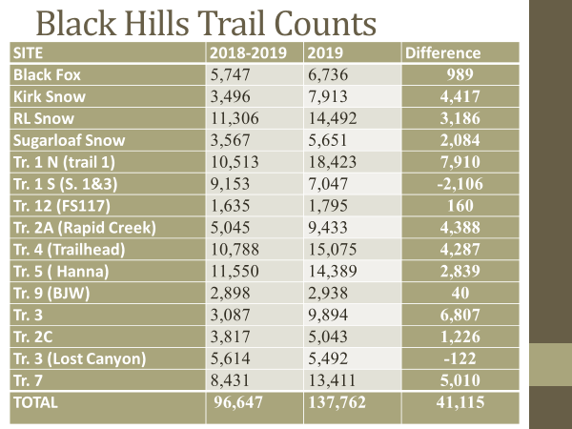
Black Hills Revenue

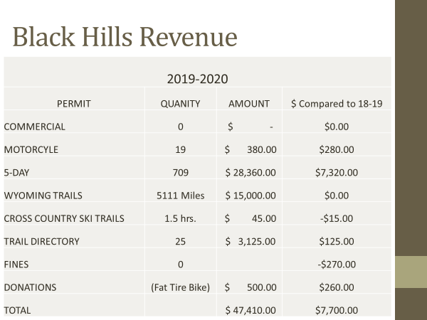

Raynor told the council they couldn’t cumulate all the 5-Day Temporary Permits prior to this meeting due to getting the permits back so late. Raynor reminded the council he purposely left last year’s numbers on the PowerPoint and will plan to share the updated figures in August.

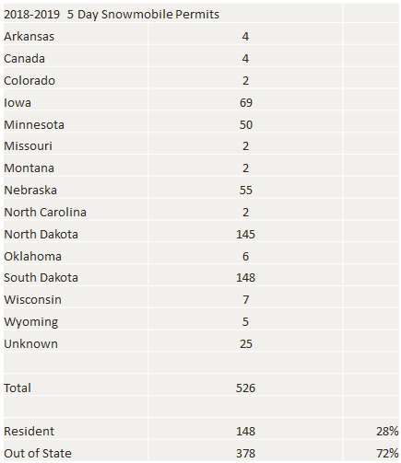

Forest Service Meeting
Due to Covid-19, the Forest Service cancelled the annual wrap-up meeting which usually takes place in August. Percy stated he’ll be asking for 1 reroute and knows the timber industry asked for one.

Percy is asking for a reroute at Stanton Draw off Moskee Road on Trail #3 and then Trail #8 logging wrapped up this season, so that trail will be moved back. After sharing a map to explain the Stanton Draw area, Percy stated he’ll be getting on the ground this summer to find a new route.

Percy also shared a map for Trail #8. Percy reminded the council they had to lease private property due to logging. Fortunately, he’s already got a reroute found which was shown on the map.

Fat Tire Bike Update
Percy stated the Forrest Service just sent out some dates to try a conference call with the Fat Tire Bike groups. The goal was to discuss pros and cons of how the season went. Percy stated some of the negatives included, not getting major portions of their trails signed, trail 1 didn’t get signed until February. Percy stated a lot of pre-riding was taking place before their event.

Percy also stated there is still no new Forrest Supervisor either. Kelly Weaver asked if nothing changed for next year, would they be allowed on the snowmobile trails starting December 15th instead of the January 15th for this season? Percy stated that would be his guess.

Camera and Website Statistics
Raynor shared the following information related to https://gfp.sd.gov/snowmobiling/.

20,173 Page Views – Total number of pages viewed. Repeated views are counted.
2:54 average time on page – The average amount of time users spent viewing a specified page or screen, or set of pages or screens.
28% Bounce Rate – The percent of visits that are single-page only. (People who visit one page and leave) Usually a high bounce rate is a sign that people are leaving y our site/pages because they aren’t finding what they are looking for. 26-46% is excellent and 41-55% is average. Bounce rate is the equivalent to an A+

Fiscal Year 2020 Budget Review
Raynor reminded the council due to the earlier May meeting, the final expense reports for the month of April have not been provided yet. This means, the figures you see below are comparing FY19 and FY20 through the end of March.

The slides below will show the Black Hills budget, then a full program summary including the Black Hills, East River GIA Program and any other administrative costs.
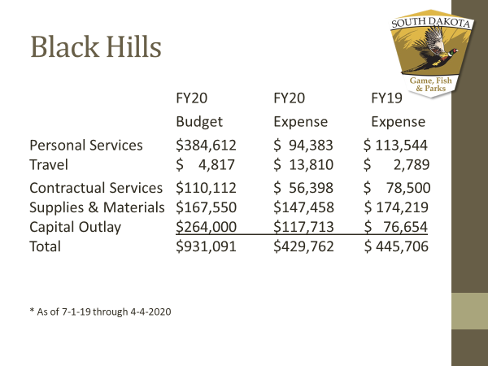

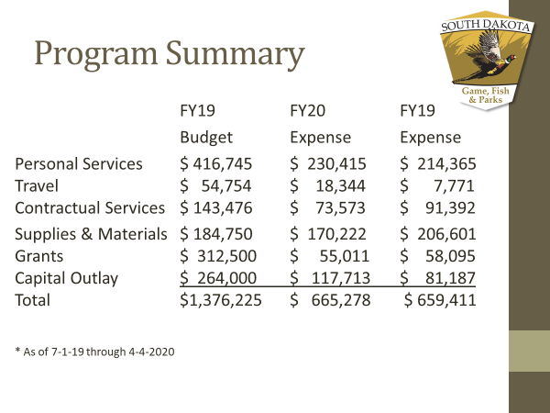
FY 20 Revenue
Raynor reminded the council the figures below are through the month of March.
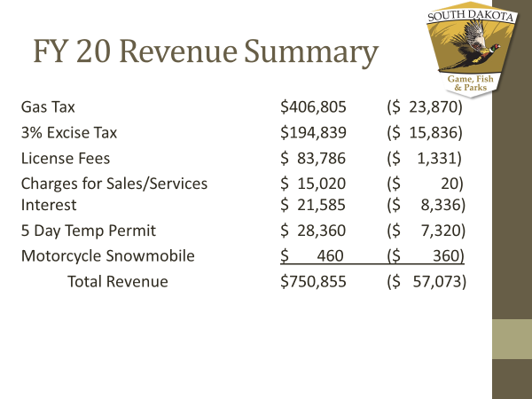

Fiscal Year 20 Grant-In-Aid
A total of $131,043 was spent to date out of the GIA budget. Raynor reminded the council these costs are covering our fixed expenses including, signing costs, private easements, insurance, fuel, grooming, maintenance and repairs and groomer storage. Raynor also reminded the council that Mitchell’s trail system was not placed this season due to flooded right of ways. He pointed out that clubs in the Coteau Des Prairie system had a great year along with the north east.

The following is a breakdown of the club’s total expenses through the GIA budget.

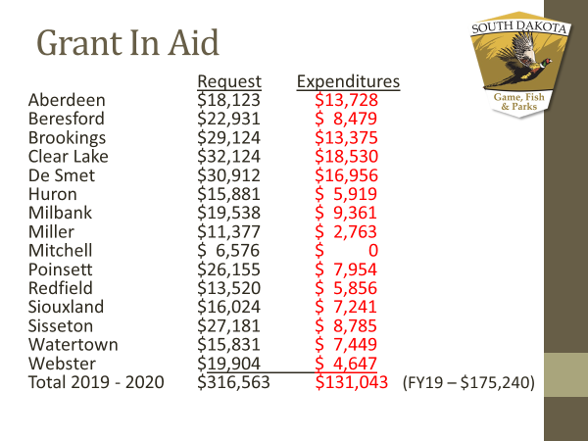

Raynor shared the following breakdown of hours put on the groomers:

Aberdeen – 215 Miller – 32
Beresford – 0 Mitchell – 0
Brookings – 181 Poinsett – 119
Clear Lake – 235 Redfield - 67
De Smet – 206 Siouxland – 85
Huron – 25 Sisseton – 132
Milbank – 151 Watertown – 96
Webster - 24

Total Grooming Hours in FY20 – 1,568
Total Grooming Hours in FY19 – 2,271

Fiscal Year 20 Grant-In-Aid Proposals
Raynor discussed the proposals received for next season including the use of 12 state-owned groomers, three privately-owned groomers, 1,064 miles of trail and 1,403 groomed miles. Total Funding request of $311,301

Most of the G.I.A. proposals are keeping their trail systems the same as the previous season. Raynor did mention he knows three clubs are still looking at potential reroutes and expects minor changes to the funding levels, to approve in August.

The following are the proposed trail changes for the Eastern South Dakota trail system for the 2019-2020 snowmobile seasons:

Brookings: Small increase in grooming miles adjusted for accuracy.

De Smett: Adding back a four-mile spur from Lake Norden to highway 81. 13-mile spur from Oldham to Heartland Corner is back after being dropped due to flooding. Loop around De Smet eliminated and changing signing to get snowmobiles through town. Still assessing exact route to get through town.

Miller: Looking at reroutes to get to St. Lawrence.

Mitchell: Anticipate a full trail system with no flooding issues

Poinsett: Removing trail spur from Estelline to Bruce due to lack of use.

Watertown: Looking at a different route into Pelican Lake which will most likely change to coming off highway 81.

The following chart shows the Grant-In-Aid requests for the 2020-2021 snowmobile season broken down by each expense category:

Club | Fuel | Maintenance | Grooming | Signing | Lease | Insurance | Rental | Total
Aberdeen | $6,318 | $3,040 | $4,750 | $1,440 | $0 | $1,075 | $1,500 | $18,123
Beresford | $0 | $0 | $20,148 | $1,460 | $400 | $923 | $0 | $22,931
Brookings | $10,507 | $5,056 | $7,900 | $2,480 | $0 | $2,000 | $1,500 | $29,443
Clear Lake | $0 | $0 | $29,808 | $1,340 | $0 | $975 | $0 | $32,123
DeSmet | $0 | $0 | $39,192 | $2,080 | $0 | $1,002 | $0 | $42,274
Huron | $5,486 | $2,640 | $4,125 | $1,100 | $0 | $1,030 | $1,500 | $15,881
Milbank | $6,983 | $3,360 | $5,250 | $1,320 | $0 | $1,125 | $1,500 | $19,538
Miller | $4,123 | $1,984 | $3,100 | $620 | $0 | $950 | $600 | $11,377
Mitchell | $1,895 | $912 | $684 | $660 | $0 | $925 | $1,500 | $6,576
Poinsett | $7,567 | $3,640 | $5,688 | $1,240 | $0 | $940 | $1,500 | $20,575
Redfield | $4,655 | $2,240 | $3,500 | $700 | $0 | $925 | $1,500 | $13,520
Siouxland | $5,387 | $2,592 | $4,050 | $1,560 | $0 | $975 | $1,460 | $16,024
Sisseton | $10,141 | $4,880 | $7,625 | $2,060 | $0 | $975 | $1,500 | $27,181
Watertown | $5,054 | $2,432 | $3,800 | $1,520 | $600 | $925 | $1,500 | $15,831
Webster | $7,066 | $3,400 | $5,313 | $1,700 | $0 | $925 | $1,500 | $19,904
Totals | $75,182 | $36,176 | $144,933 | $21,280 | $1,000 | $15,670 | $17,060 | $311,301

Safety Report
Raynor gave a brief overview of the past years reported accidents. There were 25 accidents reported with 0 fatalities (24 accidents in the Black Hills and 1 accident reported East River.) 19 out of 25 accidents were on rentals. Kelly Weaver suggested the department send a letter to the trailside businesses that would provide information on snowmobile safety and other resources to help drop that statistic. The assumption being many who rent a snowmobile, especially those who do get in an accident, are first time snowmobilers. In turn, the trailside businesses could forward that information on prior to the rental date.

Next Meeting
The next meeting is tentatively scheduled for Saturday, August 1st, 2020 at 9:00 a.m. with the intent of having a face to face meeting if approved. Otherwise a Microsoft Teams or Zoom call will be scheduled.

Adjournment
A motion was made by Hintz and seconded by Wilkinson to adjourn the meeting at 10:30 a.m. Motion Carried.

