ED ONLINE MARCH 2020
(Kodi, I’m awaiting approval on this and another story, which I’ve also highlighted in pink. So please just consider them placeholders for the time being.)
SECRETARY’S COLUMN: Wóokiye Project is an opportunity to expand teacher capacity
South Dakota has a tremendous resource in the Oceti Sakowin Essential Understandings and Standards, which explain the core concepts for understanding and teaching Lakota, Dakota, and Nakota history and culture. The Wóokiye Project will seek to build educators’ capacity for implementing the OSEUs in their classrooms and schools. LINK TO
SECRETARY’S COLUMN: Wóokiye Project is an opportunity to expand teacher capacity
South Dakota has a tremendous resource in the Oceti Sakowin Essential Understandings and Standards, which explain the core concepts for understanding and teaching Lakota, Dakota, and Nakota history and culture.
Office of Indian Education Director Juliana White Bull-Taken Alive has secured Bush Foundation funding for an exciting initiative, called the Wóokiye Project. “Wóokiye” is a Lakota term meaning to help, aid, and assist. This project seeks to help, aid, and assist teachers in implementing the OSEUs.
A teacher’s confidence is crucial to their success. Teachers tend to be confident in their ability to work with a particular age group or content area, like math, English language arts, or science.
Culture, though, can be intimidating, whether we are teaching about our own or someone else’s. There is frequently anxiety about “doing it wrong.” We don’t want to offend anyone or make a mistake, and therefore we run the risk of avoiding the topic all together.
The Wóokiye Project, beginning this summer, will seek to address this issue by building educators’ capacity (and confidence) for implementing the OSEUs in their classrooms and schools by establishing a support network. This will be an opportunity to amplify the OSEU work already happening in some schools and to build it up in others.
Participants will create a schoolwide plan for implementing the OSEUs and supporting culturally responsive teaching practices.
I hope your school will consider applying to participate in the project. Teachers may apply individually. Administrators who wish to apply as a pilot school need to have five of their teachers apply as well. More information is available on the Office of Indian Education’s Wóokiye Project webpage.
Thank you for all you do for South Dakota students.
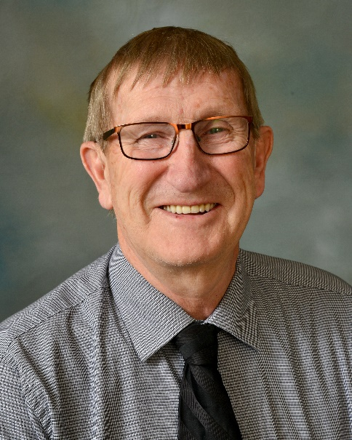
LEADER FEATURE: Ron Swier recognized as School Counselor of the Year
Ron Swier, K-12 school counselor at the Avon School District, was recently honored amongst top school counselors from across the nation during the American School Counselor Association’s School Counselor of the Year celebration in Washington, D.C. Congratulations, Ron! LINK TO
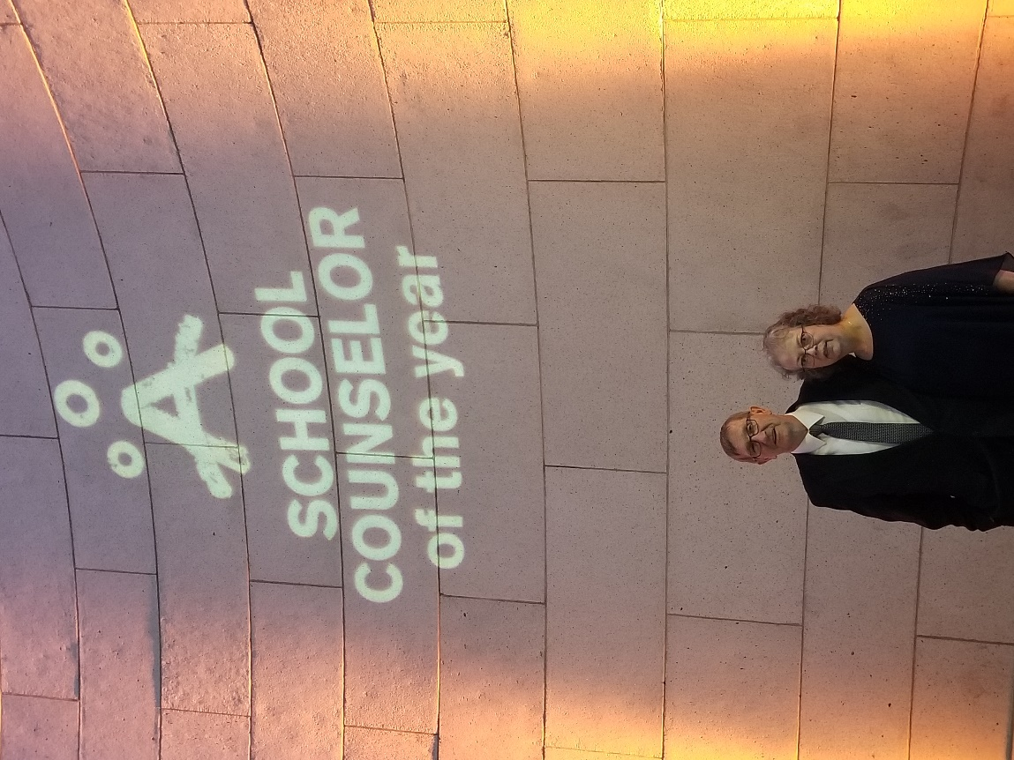
LEADER FEATURE: Ron Swier recognized as School Counselor of the Year
Ron Swier, K-12 school counselor at the Avon School District, was recently honored amongst top school counselors from across the nation during the American School Counselor Association’s (ASCA) School Counselor of the Year celebration in Washington, D.C.
ASCA’s School Counselor of the Year Celebration aims to recognize state school counselors of the year for their student advocacy and dedication to fostering students’ academic, social/emotional, and career development.
The following profile of Ron Swier is courtesy of the American School Counselor Association:
Ron Swier is South Dakota School Counselor of the Year and the school counselor in the Avon School District 4-1, serving 240 students, grades K–12.

“I am grateful for having the opportunity not only to guide my students’ development in fulfilling their best academically but more importantly by working with each one of my students to encourage a lifelong character foundation that focuses on trust, respect, responsibility, fairness, caring, and good citizenship,” Swier said.

Inspired by a Martin Luther King, Jr. quote about the function of education, Swier strives to help his students develop positive character that will last a lifetime as well. To decrease the number of negative behaviors, Swier teaches an educational program with first- through sixth-graders that focuses on building character. After discussing each character pillar, students watch motivational videos and then discuss personal experiences of how they exhibited each specific positive behavior. Classroom activities follow. By year’s end, teachers and staff reported a marked improvement in overall student behavior. For high school students, Swier initiated a student-of-the-quarter contest, calculating the award on GPA and attendance for the quarter. The winner receives a designated school parking spot along with a poster with the student’s photo displayed in the school lunchroom.

To inform students and their families about financial aid, scholarships, and future employment opportunities, Swier has organized annual financial aid nights and career fairs. He also provides one-on-one career counseling sessions. During the 2018-2019 school year, 10 students in a class of 15 received higher education scholarships totaling $270,000. Three of his students were chosen from more than 1,000 applicants nationwide to be among 365 recipients of the Build Dakota Scholarship, which funds tuition and fees to enter a critical needs workforce area.

Swier was a finalist for the South Dakota Governor’s Volunteer of the Year Award. He has a master’s degree in educational administration and a master’s degree in counseling from South Dakota State University. He has a bachelor’s degree in education from South Dakota State University. He is a member of ASCA, the South Dakota School Counselor Association, and the South Central Cooperative Counselors’ Chapter.

HOT TOPICS
Apply by March 31 to participate in Wóokiye Project
Beginning this summer, the Wóokiye Project, supported through a Bush Foundation grant, will be an opportunity for 20 South Dakota teachers to create and implement a network of support that will help, aid, and assist them as they become proficient in using the Oceti Sakowin Essential Understandings and Standards. Learn how you and educators at your school can apply to participate. LINK TO
Apply by March 31 to participate in Wóokiye Project
Beginning this summer, the Wóokiye Project, supported through a Bush Foundation grant, will be an opportunity for 20 South Dakota teachers to create and implement a network of support that will help, aid, and assist them as they become proficient in using the Oceti Sakowin Essential Understandings and Standards. “Wóokiye” is a Lakota term meaning to help, aid, assist.
South Dakota’s Office of Indian Education is seeking three pilot schools (public, non-public, or tribal/BIE) with five interested, motivated teachers from each school and an additional five at-large teachers from around the state, who will be recognized as Wóokiye teachers.
Wóokiye teachers will receive training this summer and will attend required monthly virtual meetings. Each Wóokiye teacher will be paid $1,500 for the year.
The three schools will also receive schoolwide professional development.
Schools and educators are invited to apply, regardless of their level of familiarity with implementing the OSEUs. The goal of the project is to amplify the efforts of schools already seeing success with the OSEUs, as well as those who are just beginning such work.
Wóokiye objectives:
- Creating OSEU lessons and schoolwide plans
- Modeling of culturally responsive classroom instruction
- Culturally responsive training/cultural proficiency
- Development of shared leadership/vision
- Wóopȟe Sakowin classroom management training
How to apply:
Teachers may apply individually. Administrators who wish to apply to become one of the three pilot schools need to have five of their teachers apply as well. Applications are due March 31.
Find more information, including a recorded webinar and the application, on the Office of Indian Education’s Wóokiye Project webpage.

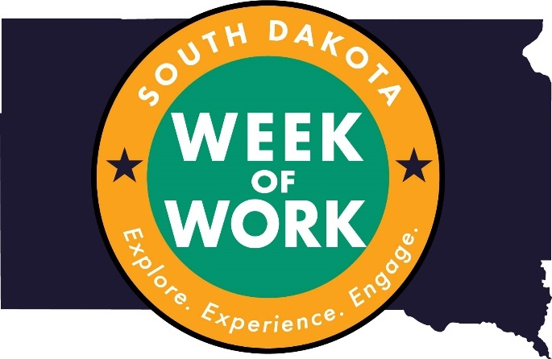
Hundreds of SD Week of Work opportunities available
It’s time for schools to begin registering their 10th graders for the first-ever South Dakota Week of Work. More than 2,900 diverse opportunities – job shadows and industry tours – exist at organizations across the state. Go to sdweekofwork.com, register your school, and then register your students for opportunities that meet their interests. LINK TO
Hundreds of SD Week of Work opportunities available
It’s time for schools to begin registering their 10th graders for the first-ever South Dakota Week of Work. More than 2,900 opportunities – job shadows and industry tours – exist at organizations across the state.
The opportunities are diverse and include the following:
- Following an emergency manager
- Experiencing nursing care with simulated patients
- Touring a festival and events business
- Learning about cuts of meat with a butcher
- Learning bookkeeping with an accountant
- Touring a genetics counseling facility
- Participating in a live on-air radio experience

Take steps now to get your students connected with businesses in your area. Go to sdweekofwork.com, register your school, and then register your students for opportunities that meet their interests.
Questions? Contact Joe Rainboth at the Department of Education, 605-220-3441.

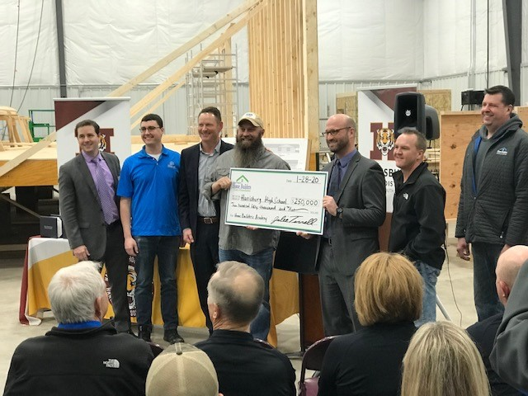
Apply by March 27 for Workforce Education Grants
The South Dakota Department of Education is accepting applications for the 2020 Workforce Education Grants. This is your chance to dream big and make transformative changes to your district’s career and technical education programs. LINK TO the following:
Apply by March 27 for Workforce Education Grants
The South Dakota Department of Education is accepting applications for the 2020 Workforce Education Grants. This is your chance to dream big and make transformative changes to your district’s career and technical education programs.
- What have you always wanted to make happen in your career and technical education programs?
- What kind of career guidance programs have you hoped to create?
- In what ways could your current programs be revised to align with today’s high-tech, knowledge-based industries?
- What partnerships have you wanted to establish or grow, but haven’t had the resources to dedicate to the effort?
- What kinds of work-based learning experiences have you hoped to incorporate in your students’ education?
- In what ways have you wanted to customize students’ educational experiences?
- What would it take to blur the lines between academic learning and career preparation?
Resources, including guidance, examples of past projects, and the application, are available on the Department of Education's Workforce Education Grants webpage. Questions can be directed to Kara Schweitzer, 605-220-3381.
Applications are due March 27. Awards will be announced by April 20.
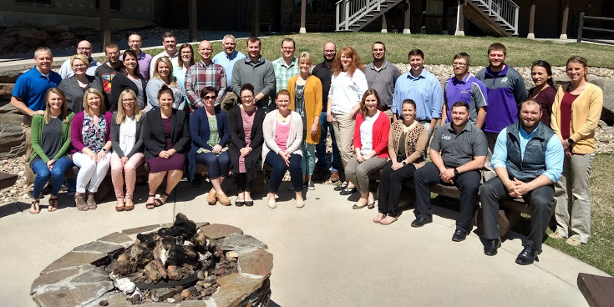Looking for candidates: Aspiring School Leaders Retreat
School administrators, please consider nominating one of your finest teachers to attend the Aspiring School Leaders Retreat, which is designed for teachers viewed as strong candidates for school administration roles. Participants must be nominated by a supervising administrator in order to apply. Applications are due by March 20. LINK TO
Looking for candidates: Aspiring School Leaders Retreat
School administrators, please consider nominating one of your finest teachers to attend the Aspiring School Leaders Retreat, April 28-29, in the Black Hills. The retreat is designed for teachers viewed as strong candidates for school administration roles; it affords them an opportunity to learn about leadership roles, reflect on their careers, and consider a pathway leading to administration.
Participants must be nominated by a supervising administrator in order to apply. Applications are due by March 20. The retreat is limited to 30 participants. For more information and the application, click here.
This event is a collaboration of the South Dakota Department of Education, School Administrators of South Dakota, and TIE.

HEADLINES
(Kodi, please use this picture with the headline and blurb)
Testing windows open in March and April
Testing windows for statewide assessments in math, English language arts, and science open in March and April. Find more information on the Department of Education's Office of Assessment website. Questions? Email doeassessment@state.sd.us
- SD English Language Arts and Math Assessments: March 4-May 1
- SD English Language Arts and Math Alternate Assessments: March 16-May 1
- SD Science Assessment and Alternate Assessments: April 1-May 1

Kodi, I’m waiting for Becky to review this story, and there will be some changes. So please just consider this a placeholder for now.
Students in grades 5, 8, 11 to take field test in science this spring
This is a field test year for the South Dakota Science Assessment, which is administered to students in grades 5, 8, and 11. The test is computer adaptive and will assess all three dimensions of the South Dakota Science Standards, adopted in 2015: Disciplinary Core Ideas, Science and Engineering Practices, and Crosscutting Concepts. LINK TO
Students in grades 5, 8, 11 to take field test in science this spring
This is a field test year for the South Dakota Science Assessment, which is administered to students in grades 5, 8, and 11. The test is computer adaptive and will assess all three dimensions of the South Dakota Science Standards, adopted in 2015: Disciplinary Core Ideas, Science and Engineering Practices, and Crosscutting Concepts.
Standard setting will take place this summer. In coming months, the Department of Education will be recruiting for volunteers to help with this process.
This new test is intended to provide more information to educators, similar to the claims and targets available from the South Dakota English Language Arts and Math Assessments. Due to the length of the test, it will not be possible to drill down to the standard level for each student.
The department is still working to determine how science test scores will be handled on the 2019-20 Report Card. Currently the only calculations for science included on the report card are “Participation” and “All-Assessed.” The science averages shown on the report card are an informational requirement of the Every Student Succeeds Act.

Submit public comment on proposed rule changes by March 11
The Board of Education Standards will hold a public hearing regarding proposed rule changes at its March 16 meeting in Mitchell. The effect of the proposed changes is to update state Administrative Rule to accurately reflect the federal Individuals with Disabilities Education Act, as amended by the Every Student Succeeds Act, and to correct the definition of preschool age and preschool program to align with IDEA preschool age. LINK TO
Submit public comment on proposed rule changes by March 11
The Board of Education Standards will hold a public hearing regarding proposed rule changes at its March 16 meeting in Mitchell. The effect of the proposed changes is to update state Administrative Rule to accurately reflect the federal Individuals with Disabilities Education Act, as amended by the Every Student Succeeds Act, and to correct the definition of preschool age and preschool program to align with IDEA preschool age.
One of the primary changes is to eliminate references to “highly qualified” teachers. Under ESSA, teachers must meet the certification requirements of their state, rather than a separate definition of highly qualified. Find the rules at rules.sd.gov and follow the Department of Education hot link. You can also offer public comment via this site; the deadline is March 11.
New suicide prevention resource available for schools
A snapshot of suicide prevention resources for schools is available through the sdsuicideprevention.org website. Awareness campaigns, school-based suicide prevention curriculum, suicide prevention training, and additional resources are featured on a two-page document. The document is also linked on the Department of Education's Mental Health webpage, or you may access it here.

(Kodi, could you please make the thumbnail LINK TO https://doe.sd.gov/sped/documents/parentalrights-HB.pdf)
Updated Parental Rights handbook available
The format of the South Dakota Department of Education’s Parental Rights Handbook has been updated, and it is now designed to be more parent-friendly. The updated handbook is located on the department’s Parental Rights webpage. Coming soon: Spanish version and additional languages. Note: content and processes have not changed.
Planning Comprehensive Needs Assessment workshops for 2020-21
The South Dakota Department of Education will host year-long regional South Dakota Comprehensive Needs Assessment workshops in the 2020-21 school year. School districts are invited to complete a brief survey to help the department gauge interest and determine dates and locations. Completing a survey is not a commitment to participate. LINK TO
Planning Comprehensive Needs Assessment workshops for 2020-21
When’s the last time your school conducted a comprehensive needs assessment? Where do you even start? Who can you call for help? Is there a tool you can use?
The South Dakota Department of Education will host year-long regional South Dakota Comprehensive Needs Assessment workshops in the 2020-21 school year. School districts are invited to complete a brief survey to help the department gauge interest and determine dates and locations. Completing a survey is not a commitment to participate.
The workshops are intended for schools identified for school improvement (targeted support and improvement), Title I schoolwide schools, and any school that would like support conducting a needs analysis. Schools will navigate the process with the support of a facilitator trained in the South Dakota Comprehensive Needs Assessment process.
Title I schoolwide schools are required to conduct a needs assessment aligned to the framework by the end of the 2020-21 school year and once every three years. Title I schoolwide schools are encouraged to participate if they have not done so already.
The series consists of five in-person sessions:
- Half day: introduction meeting and overview of the process
- Full day: in-depth session on the four components, brainstorm data sources, crosswalk data sources, engaging stakeholders
- Two full days: data work, complete summary templates
- Full day: prioritize needs, root cause analysis
- Full day: action planning
School teams must commit to attend all five in-person sessions, send a team of three to five members, and complete the homework assigned between sessions. The process is designed to build a school’s capacity in conducting the needs analysis, looking at both qualitative and quantitative data sources.
Please contact Jordan Varilek for more information on the SDCNA and/or the workshop series.

(Kodi, could you please make this photo the full column width and have it LINK TO https://youtu.be/zPInTwy8VnA)
Encourage your experienced teachers to become mentors
The Statewide Mentoring Program provides a first-year teacher access to a mentor teacher for a period of two years and participation in a summer academy following the first and second year of employment. Applications for the 2020-21 school year are now open. LINK TO the following:

Encourage your experienced teachers to become mentors
The Statewide Mentoring Program provides a first-year teacher access to a mentor teacher for a period of two years and participation in a summer academy following the first and second year of employment.

Applications for the 2020-21 school year are now open.
This is an excellent opportunity for experienced South Dakota teachers (current and retired) to share their skills and help guide beginning teachers. In addition, through this program, South Dakota’s newest teachers are supported and welcomed into the education community.
Mentors and new teachers who complete the mentoring program meet the credit requirements to renew their teaching certificate.
Alternative Certification teachers are required to participate in a state-approved mentoring program. Those who are in the Statewide Mentoring Program meet this requirement.
Requirements have also been established for districts that would like to receive funding to handle mentoring locally.
Visit the Statewide Mentoring Program’s webpage to learn more and find the following:
- Applications for new mentors and first-year teachers
- Program information for second-year participants
Those who are already participating in the program are not required to complete a new application.
How can I showcase my district’s emerging teacher leaders?
The South Dakota Department of Education maintains a list of Emerging Classroom Leaders, which consists of distinguished teachers and principals from across the state. These educators are considered for membership on advisory boards and task forces, and as candidates for special recognition programs. LINK TO

How can I showcase my district’s emerging teacher leaders?
The South Dakota Department of Education maintains a list of Emerging Classroom Leaders, which consists of distinguished teachers and principals from across the state. These educators are considered for membership on advisory boards and task forces.

In addition, they represent their communities and our state, and may ultimately receive prestigious recognition. The Department of Education is seeking to add classroom teachers and/or principals to the Emerging Classroom Leaders Pool, who have demonstrated all of the following:

- Exceptional educational talent as evidenced by effective instructional practices and student learning results in the classroom and school
- Exemplary educational accomplishments beyond the classroom that provide models of excellence for the profession
- Individuals whose contributions to education are largely unheralded yet worthy of the spotlight
- Early- to mid-career educators who offer strong long-range potential for professional and policy leadership and
- Engaging and inspiring presence that motivates and impacts students, colleagues, and the community

Please submit recommendations by ???

To recommend an educator:
- Complete one Talent Pool Recommendation Form for each candidate with confidential, succinct, and specific information. All questions must be answered. Typewritten submissions are preferred.
- Write a one-page letter that addresses how the candidate meets the previously mentioned criteria.
- Obtain a copy of the candidate’s resume.

UPCOMING EVENTS
A complete listing of events is available at GoSignMeUp.
Essential Skills for Success – Teaching Kids to Thrive
March 9-April 17, online book study course
Title Programs webinars
3:30-4:30 p.m. CT
March 10 – Build It and They Will Come K-12
March 26 – Mindfulness
April 6 – How to Prevent Summer Slide K-5
April 23 – STEM in a Bag
See It In Action! Day – Rural CTE Programs
March 11, Webster
Board of Education Standards
March 16, Mitchell
Strengthening relationships with all families with an emphasis on EL/Migrant families
March 17, Sioux Falls
South Dakota Special Education Conference
March 17-18, Sioux Falls
SD-STARS topical webinar
March 25
Spring DOE/Infinite Campus user groups
March 31-April 3, various locations statewide
For more information, contact Judy Merriman or Teri Jung

SD Advisory Panel for Children with Disabilities
April 2, Pierre

TIE Conference
April 19-21, Sioux Falls
South Dakota Early Childhood Education Conference
April 23-25, Sioux Falls

Looking Back on South Dakota History with 20/20 Vision
State Historical Society History Conference
April 24-25, Pierre
SPED Spring Legal Update
April 28, webinar
Grants Management Workshop – Consolidated Application Technical Assistance Opportunity
April 28, 9 a.m. CT, Pierre
April 28, 1 p.m. CT, Pierre
April 29, 9 a.m. CT, Pierre
April 29, 1 p.m. CT, Pierre
SD Education Conference
May 27-28, Oacoma
- Don’t miss the Pre-Conference event sponsored by Project AWARE!

(Kodi, could you somehow set the following apart a bit, with a Save the Date heading and making the text italicized? I realized I’d built up more Save the Dates than usual in this issue.)
Save the Date
Top 20 Training
July 28-30, Chamberlain

ExCITE! (formerly School Library Boot Camp)
Sept. 30, Aberdeen, and online through October

Indian Education Summit & Conference
Oct. 15-17, Pierre

UPCOMING EVENTS (PRINT VERSION)
Except where otherwise noted, details on the following events are available at GoSignMeUp (http://southdakota.gosignmeup.com/).
Essential Skills for Success – Teaching Kids to Thrive
March 9-April 17, online book study course
Title Programs webinars
3:30-4:30 p.m. CT
(https://doe.sd.gov/pressroom/educationonline/2020/Feb/documents/Webinars.pdf)
March 10 – Build It and They Will Come K-12
March 26 – Mindfulness
April 6 – How to Prevent Summer Slide K-5
April 23 – STEM in a Bag
See It In Action! Day – Rural CTE Programs
March 11, Webster
Board of Education Standards
March 16, Mitchell (https://boardsandcommissions.sd.gov/Meetings.aspx?BoardID=32)
Strengthening relationships with all families with an emphasis on EL/Migrant families
March 17, Sioux Falls
South Dakota Special Education Conference
March 17-18, Sioux Falls (https://www.eventbrite.com/e/2020-south-dakota-special-education-conference-tickets-73860784595)
SD-STARS topical webinar
March 25

Spring DOE/Infinite Campus user groups
March 31-April 3, various locations statewide
For more information, email judy.merriman@state.sd.us or teri.jung@state.sd.us

SD Advisory Panel for Children with Disabilities
April 2, Pierre (https://boardsandcommissions.sd.gov/Meetings.aspx?BoardID=16)

TIE Conference
April 19-21, Sioux Falls (https://www.eventsquid.com/event.cfm?event_id=8310)

South Dakota Early Childhood Education Conference
April 23-25, Sioux Falls (https://sdececonference-org.doodlekit.com/home/registration)
Looking Back on South Dakota History with 20/20 Vision
State Historical Society History Conference
April 24-25, Pierre (https://history.sd.gov/aboutus/HistoryConference/)
SPED Spring Legal Update
April 28, webinar
Grants Management Workshop – Consolidated Application Technical Assistance Opportunity
April 28, 9 a.m. CT, Pierre
April 28, 1 p.m. CT, Pierre
April 29, 9 a.m. CT, Pierre
April 29, 1 p.m. CT, Pierre
SD Education Conference
May 27-28, Oacoma (https://doe.sd.gov/title/2020-conference/index.aspx)
- Don’t miss the Pre-Conference event sponsored by Project AWARE!

(Kodi, could you somehow set the following apart a bit, with a Save the Date heading and making the text italicized? I realized I’d built up more Save the Dates than usual in this issue.)
Save the Date
Top 20 Training
July 28-30, Chamberlain

ExCITE! (formerly School Library Boot Camp)
Sept. 30, Aberdeen, and online through October

Indian Education Summit & Conference
Oct. 15-17, Pierre

