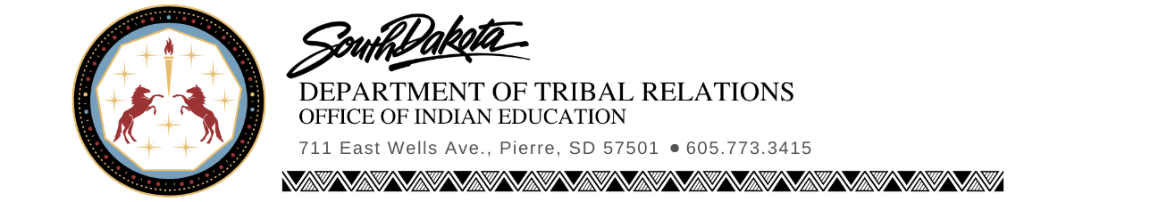
Indian Education Advisory Council
SD Department of Indian Education
2:00 to 4:00 CST
Thursday, September 23rd 2021
Zoom

Meeting was called to order by Director Osborn at 2:04 PM. Roll call was then recorded.
Present Remote: Angel Lee, Ann Robertson, Cheryl Medearis, Dr. Cherie Farlee, Dr. Sherry Johnson, Everall Fox, Jacqueline Sly, Karyl Knudson, Kay Schallenkamp, Megan Deal, Loren Paul
Absent: Charles Cuny, Cindy Young, Dayna Brave Eagle, Emma Jean Blue Earth, Gail Swenson, Jolene Arrow, Josie A. Green, Katherine Erdman-Becker, Lisa Bordeaux- Taken Alive, Sarah Pierce, Whitnee Pearce
Others Present: Beth Schneider (DOE/JAG-SD), RoseMary Clairmont (TED), Bob Mercer (Keloland Media)
Welcome of attendees by Director Osborn with prayer by Dr Johnson.
Approval of Agenda: Motion made by Jacqueline Sly to approve the agenda as amended, seconded by Cheryl Medearis. Motion passed by voice consent.
Approval of Minutes: Motion was made by Jacqueline Sly to approve the 28JUN21 IEAC minutes. Motion seconded by Dr. Johnson to pass minutes as amended. Motion passed by voice consent.
Agenda Item: Wóokiye Project Update
Director Osborn notified the IEAC of the two schools that are joining the Wóokiye Project, bringing the total to five Pilot Schools and thirty teachers. The new Wóokiye teachers will be attending OSEUS and Cultural Proficiency training with TIE on September 26th and 27th at the Ramkota in Pierre. The project now has three Wóokiye Project Schools on tribal lands and two public schools, for a wide range of responses and participation. An overview of the Wookiye Project was then given for the new members of the IEAC. The mailing of the OSEUS to all schools in South Dakota, along with copies of the OSEUS in Braille for those in need was discussed as part of the Wóokiye Project. Discussion followed.
Agenda Item: 2021 SD Indian Education Conference Update
Director Osborn discussed the change in date for the Summit and announced that the registration will be opening for the event next week. He specified that the registration link will be sent out to the IEAC, will be found on the DTR website, and other platforms. He mentioned that the focus this year is on the social and mental wellbeing of the students. Discussion Followed.
Agenda Item: SD DOE Update: JAG Program and Alignment to the OSEUS – Beth Schneider (DOE/JAG-SD)
Joe Moran introduced himself and Beth Schneider who is here in place of Laura Scheibe.
Beth Schneider spoke about the JAG Program and its connections with the OSEUS. The shared a list of the schools currently participating in the program, along with some of the ways they incorporate the OSEUS into their program. They will be hosting a retreat in October to provide more OSEU confidence for their specialist, in order to help more of their students. Dr. Simpson and Sharla Steever from TIE will be educating at the Retreat. Discussion followed.
Agenda Item: SD DOE Update: Oceti Sakowin Needs Assessment Survey
Joe Moran thanked everyone for being part of the communications and development of the Oceti Sakowin needs assessment survey that was launched at the beginning of the school year. The survey was sent to all public, private, tribal, and BIE schools. The intention of the survey is to help DOE and DTR understand the support needs for the OSEUS. So far they have received 900 responses, results may not be finalized until the end of the year.
Agenda Item: SD DOE Update: IC Mapping
Joe Moran gave an overview of the IC Mapping that was developed by teachers from across the state. After the final draft is passed, they will be looking for schools that will be willing to pilot the IC mapping.
Old Business: None
New Business: SD Social Studies Standards
Director Osborn gave an overview of the SD Social Studies Standards review and the delay of them per Gov. Noem’s directive. OIE supports the Governor’s directive to delay the consideration of the revisions of the state’s social study standards for further public input. It is the mission of OIE to support initiatives in order that South Dakota's students and public-school instructional staff become aware of and gain an appreciation of South Dakota's unique American Indian culture. OIE will continue to support a true and honest account of American and South Dakota history as well as promote the OSEUS as adopted by the South Dakota State Board of Education Standards. Director Osborn ensured the IEAC members that the public commentary process will be open throughout the duration of the delay and urged them to continue to give their comments. He also reminded them that the current unpacked standards for the OSEUS are available, to assist with identifying which OSEU would be aligned to which standard and offered to have anyone who needs assistance, to reach out to the OIE for support. He then opened it up for discussion.
Next Meeting: Survey Monkey will go out for a December Meeting.
Motion to adjourn: Motion made by Loren Paul at 2:59 PM, seconded by Dr. Johnson, motion passed by voice consent.
Meeting Adjourned at 3:00 PM.
Respectfully Submitted by Trista Olsen, IEAC Secretary, on 23SEP21.

Fred Osborn Date Minutes Approved
Executive Director, SD IEAC

ABBREVIATION REFERENCE:
BOR: Board of Regents
DOE: Department of Education
IEAC: Indian Education Advisory Council
IES: Indian Education Summit
OSEU: Oceti Sakowin Essential Understandings
TIE: Technology & Innovation in Education

