

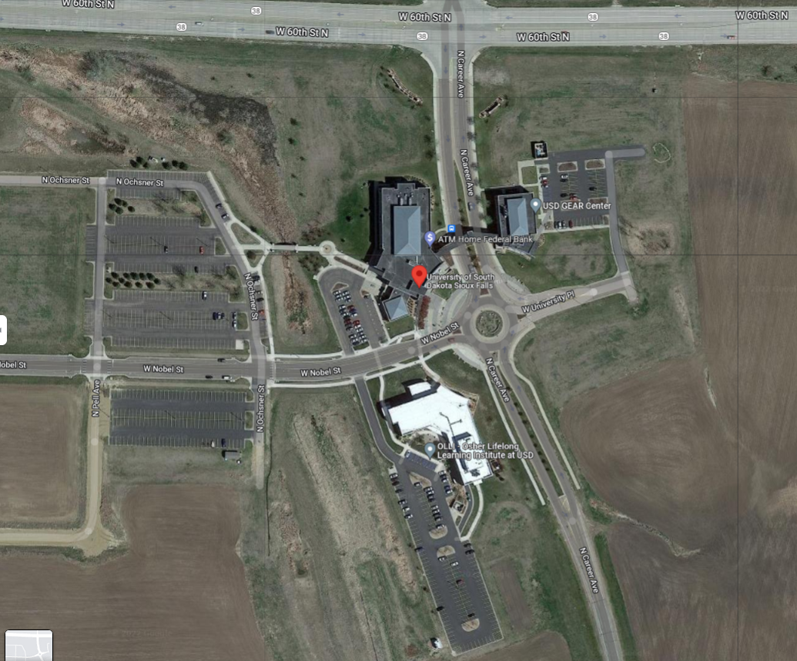

**A**

**C**

**D**

**E**

**Science & Technology (FSC1)**

**G**

**B**

**Classroom Building (FADM)**

**F**



**GEAR Center (FGER)**

USD Sioux Falls Parking Map

**Addresses**

Classroom Building  
4801 N Career Ave SF SD 57107  
  
Gear Center Building  
4800 N Career Ave SF SD 57107  
  
Science and Technology Building  
4701 N Career Ave SF SD 57107



**Parking Lot Key**

A – Northwest Lot

B – West Lot

C – West Lot

D – Southwest Lot

E – Classroom Lot (FADM)

F – Science & Technology Lot (FSC1)

G – GEAR Center Lot (FGER)

**Other Key**

Indicates Physical Entrance