Governor’s Commission on Fort Sisseton
Fort Sisseton, 11907 434th Ave, Lake City, SD 57247

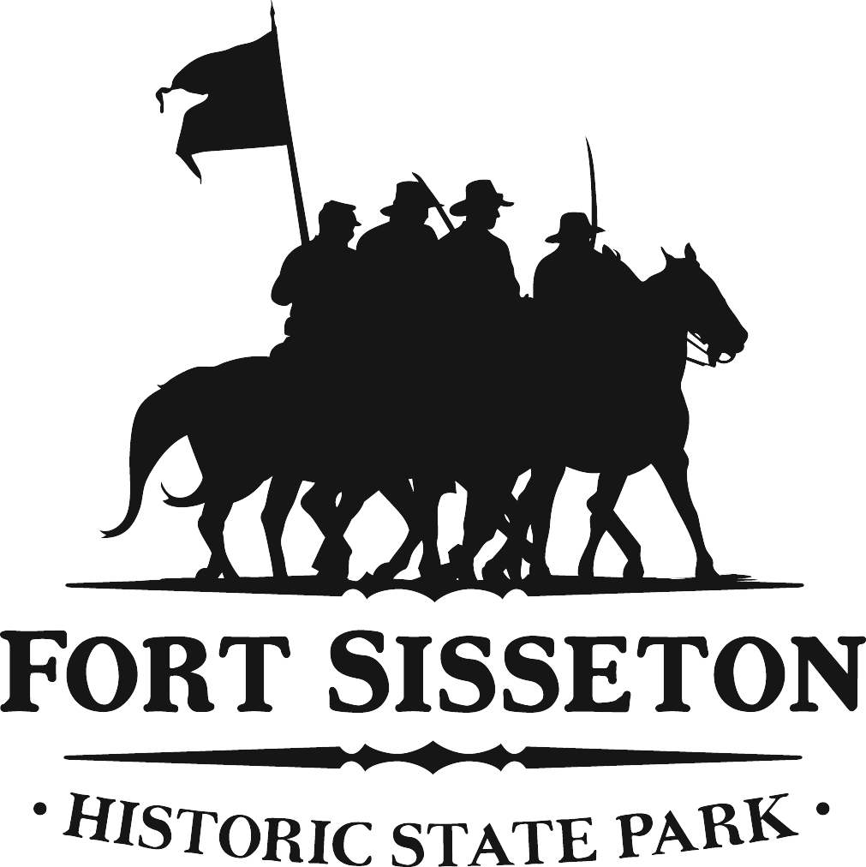

Fort Sisseton Commission Strategic Meeting
Agenda
July 12th, 2019
3pm-5pm

July 12th, 2019

3pm: Overview of last meeting with purpose in mind for the plan

3:10pm: Any new thoughts or concerns

3:30pm: Report from Subcommittee to large committee

4:00pm: Large Group Brainstorm session

4:30pm: Determine Strategic Plan Action items, timeframes and the 3 W’s (who, what, when)

5:00pm Adjourn for regular Commission Meeting

