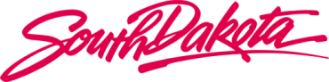

Ellsworth Development Authority
_______________________________
AGENDA

Board of Directors Meeting

9 October 2018, Tuesday, 1 pm Mountain

14 Saint Joseph Street, Suite 200, Rapid City, SD 57709
2nd Floor Bank Conference Room

Dial-In Instructions – Participant
Dial: 1 866-939-8416 Password: 1594130

- Welcome - Call to Order (1 pm)

a. Roll Call
b. Conflict of Interest Disclosure / Request for Waiver and Roll Call – Action Item

- Pursuant to SL 3-23-1 and absent a waiver, no elected or appointed member of a state authority, board, or commission may have an interest in or derive a direct benefit from any contract(s).

- Does any SDEDA BOD member have an interest in or derive a direct benefit from any existing or future contract(s)?

- Are there any requests for waivers?

- Roll Call

c. Approval of Agenda - Action Item
d. Approval of Minutes from 13 June 2018 - Board Meeting – Action Item

2. Business Updates:

- Old Business
- New Business
(1) Resolution 19-01: Consider resolution approving the sale of 21 modular units in Eastgate Estates - Action Item

3. Adjournment

