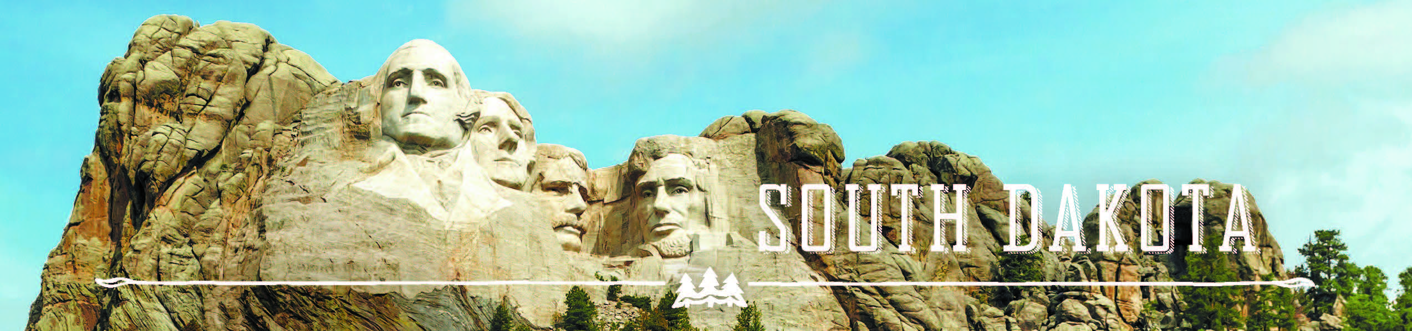

Governor’s Tourism Advisory Board Minutes
Ramkota Hotel and Convention Center, Pierre, South Dakota
January 17, 2017

Board Present
Stan Anderson
Tom Biegler
John Brockelsby
Ted Hustead
Ann Lesch
Julie Ranum
Carmen Schramm
Ivan Sorbel
Frank Smith
Kristi Wagner

Staff Present
Natasha Bothun
Wanda Goodman
Jim Hagen
Harla Jessop

Vice President Ivan Sorbel called the meeting to order and called for nominations for President.

John Brockelsby nominated Ted Hustead for another term as President of the Governor’s Tourism Advisory Board. Kristi Wagner moved to close nominations. Stan Anderson seconded. Motion carried by unanimous ballot.

Vice President Ivan Sorbel opened nominations for Vice President.

John Brockelsby nominated Ivan Sorbel for another term as Vice President of the Governor’s Tourism Advisory Board. Kristi Wagner moved to close nominations. Stan Anderson seconded. Motion carried by unanimous ballot.

Natasha Bothun handed out individual Board assignments for the Conference and gave an overview of the sessions.

Meeting was adjourned.

