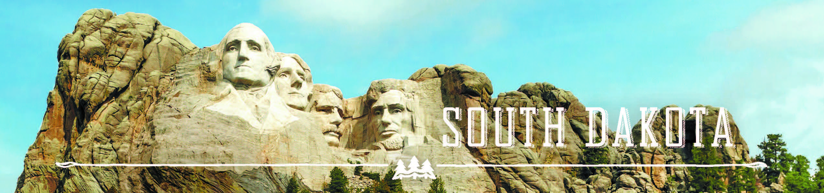

GOVERNOR’S TOURISM ADVISORY BOARD MEETING
Tuesday, January 17, 2017
Ramkota Hotel & Convention Center
Pierre, South Dakota
Draft Agenda

Amphitheatre 1
1:30 PM Call Meeting to Order, President Ted Hustead

1:35 PM Election of Officers

1:45 PM Tourism Conference Board Duties Briefing,
Conference Chair, Natasha Bothun

2:15 PM Adjourn

(Photographs of Board and New Officers, Chad Coppess)

