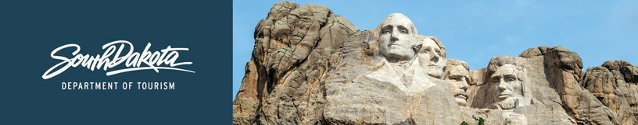

GOVERNOR’S TOURISM ADVISORY BOARD MEETING
Wednesday, September 13, 2017, 1:30 pm
Sioux Falls, South Dakota
Tentative Agenda

Comfort Inn and Suites
3721 West Avera Drive
Sioux Falls, SD 57104
605.275.9577

1:30 pm Meet in lobby of Comfort Inn and Suites

1:35 pm Bus Departs Comfort Inn and Suites for tour of Sioux Falls newest area attractions led by Sioux Falls CVB Director Teri Schmidt and staff

4:40 pm Return to Comfort Inn and Suites

Dinner on your own

GOVERNOR’S TOURISM ADVISORY BOARD MEETING
Thursday, September 14, 2017, 8:30 am
Sioux Falls, South Dakota
Tentative Agenda

Great Plains Zoo & Delbridge Museum of Natural History
KELOLAND Education Center
805 South Kiwanis
Sioux Falls, SD 57104

8:30 am Call Meeting to Order, President Ted Hustead

8:35 am Welcome and Sioux Falls Updates from Teri Schmidt, Sioux Falls CVB

8:45 am Tourism Board Member Reports

9:05 am Regional Director Reports
Karen, Kern, South Dakota Missouri River Tourism Association
Rosie Smith, Glacial Lakes and Prairies Tourism Association
Michelle Thomson, Black Hills and Badlands Tourism Association

9:25 am Meet the Marketing Agencies – Jim Hagen
Lawrence and Schiller
MMGY
Miles

10:00 am Strategic Plan, Macy’s, New Staff, Updates, Secretary Jim Hagen

10:10 am Global Media and Public Relations Update, Katlyn Richter and Keegan Carda, Tourism

10:25 am Global Marketing and Brand Strategy Update, Mike Gussiaas and Thad Friedeman, Tourism

10:45 am VEP Program Updates, Mike Gussiaas

11:00 am Great Plains Zoo & Delbridge Museum of Natural History Presentation, Elizabeth Whealy

11:10 am Guided Tour of Great Plains Zoo & Delbridge Museum of Natural History

12:30 pm Working Lunch

12:40 pm Social Media Update, Stephanie Palmer, Tourism

12:50 pm Updates on Global Travel and Trade, Cole Irwin, Tourism

1:00 pm Industry Outreach and Development Update, Secretary Jim Hagen

1:10 pm Tourism Conference, Wanda Goodman

1:20 pm Welcome Center Updates, Wanda Goodman

1:30 pm Secretary‘s Recap, Secretary Jim Hagen

1:40 pm Meeting Adjourned

