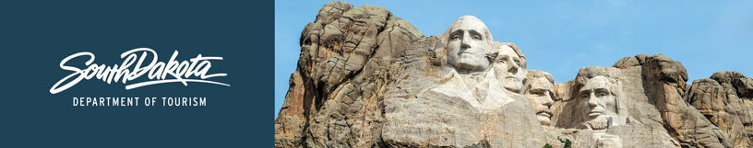

GOVERNOR’S TOURISM ADVISORY BOARD MEETING
Wednesday, September 13, 2017, 1:30 pm
Sioux Falls, South Dakota
Tentative Agenda

Comfort Inn and Suites
3721 West Avera Drive
Sioux Falls, SD 57104
605.275.9577

1:30 pm Meet in lobby of Comfort Inn and Suites

1:35 pm Bus Departs Comfort Inn and Suites for tour of Sioux Falls newest area attractions led by Sioux Falls CVB Director Teri Schmidt and staff

4:40 pm Return to Comfort Inn and Suites

Dinner on your own

GOVERNOR’S TOURISM ADVISORY BOARD MEETING
Thursday, September 14, 2017, 8:30 am
Sioux Falls, South Dakota
Agenda

Great Plains Zoo & Delbridge Museum of Natural History
KELOLAND Education Center
805 South Kiwanis
Sioux Falls, SD 57104

8:30 am Call Meeting to Order, President Ted Hustead

8:35 am Welcome and Sioux Falls Updates from Teri Schmidt, Sioux Falls CVB

8:45 am Tourism Board Member Reports

9:05 am Regional Director Reports
Karen, Kern, South Dakota Missouri River Tourism Association
Rosie Smith, Glacial Lakes and Prairies Tourism Association
Michelle Thomson, Black Hills and Badlands Tourism Association
Ryan Freiz, President and Kris Frerk, Vice President, Southeast
SD Tourism Association

9:25 am Meet the Marketing Agencies – Jim Hagen
Lawrence and Schiller
MMGY
Miles

10:00 am Strategic Plan, Macy’s, New Staff, Updates, Secretary Jim Hagen

10:10 am Global Media and Public Relations Update, Katlyn Richter and Keegan Carda, Tourism

10:25 am Global Marketing and Brand Strategy Update, Mike Gussiaas and Thad Friedeman, Tourism

10:45 am VEP Program Updates, Mike Gussiaas, Tourism

11:00 am Great Plains Zoo & Delbridge Museum of Natural History Presentation, Dave Haan, Nicole Bruning, and Kylee Breems

11:10 am Guided Tour of Great Plains Zoo & Delbridge Museum of Natural History

12:30 pm Working Lunch

12:40 pm Social Media Update, Stephanie Palmer, Tourism

12:50 pm Updates on Global Travel and Trade, Cole Irwin, Tourism

1:00 pm Industry Outreach and Development Update, Kirk Hulstein, Tourism

1:10 pm Tourism Conference, Wanda Goodman, Tourism

1:20 pm Welcome Center Updates, Wanda Goodman, Tourism

1:30 pm Secretary‘s Recap, Secretary Jim Hagen

1:40 pm Meeting Adjourned

