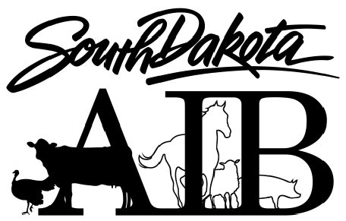 **SD ANIMAL INDUSTRY BOARD**

411 South Fort Street

Pierre, South Dakota 57501-4503

Phone: (605) 773-3321

Fax: (605) 773-5459

TTY: 1-800-877-1113

**South Dakota Animal Industry Board**

**BOARD MEETING NOTICE**

**Tuesday july 10, 2018**

The South Dakota Animal Industry Board will hold the Annual Meeting on Tuesday, July 10, 2018 at 8:30 AM central time in the Animal Industry Board conference room at 411 South Fort Street, Pierre, SD.

Notice is further given to individuals with disabilities that this meeting is being held in a physically accessible place. Please notify the South Dakota Animal Industry Board within 48 hours of the meeting if you have special needs for which this agency will need to make arrangements. The telephone number for making special arrangements is 605-773-3321.



Dustin Oedekoven, DVM

SD State Veterinarian

SD Animal Industry Board

**SD ANIMAL INDUSTRY BOARD**

411 South Fort Street

Pierre, South Dakota 57501-4503

Phone: (605) 773-3321

Fax: (605) 773-5459

TTY: 1-800-877-1113

**SOUTH DAKOTA ANIMAL INDUSTRY BOARD**

**ANNUAL MEETING**

**TUESDAY JULY 10, 2018**

**Updated Tentative Agenda**

8:30 AM Animal Health and Other Updates

* + - Trichomoniasis
    - Bovine Tuberculosis
    - Equine Herpesvirus (EHV-1)
    - Avian Health Updates
    - Senecavirus A
    - Anthrax
    - ADRDL Expansion Update
    - ARMAR Functional Exercise (May 2018)
    - Animal Identification
    - Cimpl’s
    - Dakota Rendering
    - Meat Inspection
    - Livestock Auction Market Veterinarian Meeting
    - USA-Herds

11:00 AM Auction Agency Hearing (Belle Fourche Livestock Market LLC, Baxter Anders, applicant)

Annual Report Review / Approval

Board Business

* + - Consideration of changes to brucellosis testing import testing cattle from Sheridan County, WY.
    - Consideration of request to remove brucellosis import testing requirement for cervids
    - Exam Board Joint Powers Agreement
    - USAHA dates, travel authorization

Reportable Disease List

Board Election of Officers

Executive Session

Adjourn

**Note: Scheduled times are CDT and estimates only. Agenda items may be delayed due to prior scheduled items or may be moved up on the agenda. Breaks and recess will be at the discretion of the president.**