NREC Meeting – 6/26/17
In Attendance Not In Attendance
Ryan Schuchhardt Ryan Wolf
Kevin Bachmeier Bryan Jorgensen
Paul Wegleitner
Jim Loken
Colin Nachtigal
Richard Vasgaard
Al Miron
Richard Jenny
Tom Wolles
Dana Loseke
Bill Gibbons
David Smith
Kathy Zander
Lora Berg
Justin Werkmeister
Missy Vande Weerd

The 2nd meeting of the NREC meeting was held on June 26, 2017 at the Cow Calf Teaching and Education Facility at South Dakota State University. Members that were and were not in attendance are listed above.
Term length was discussed along with by-laws. Richard Vasgaard voted to approve to bylaws with amendments’ and Richard Jenny seconded the motion. Motion passed without discussion. See by-laws document that will be sent in addition to these notes.
A financial update was then given. Funds are transferred from the state of South Dakota to SDSU. $502,000 is currently in the account. The majority of the money will be in place by July 1.
Election of officers was then held. Ryan Wolf was nominated and elected Chair. Ryan Schuchhardt and Richard Jenny were nominated for Vice Chair. Ryan Schuchhardt was elected vice chair. Nominations for treasurer were held and James Loken was elected. Nominations for secretary were held and Colin Nachtigal was elected.
Officer Team is listed below:
Chair: Ryan Wolf
Vice Chair: Ryan Schuchhardt
Treasurer: James Loken
Secretary: Colin Nachtigal

Annual Meeting and Funding Schedules were then discussed. The group decided that following the schedule
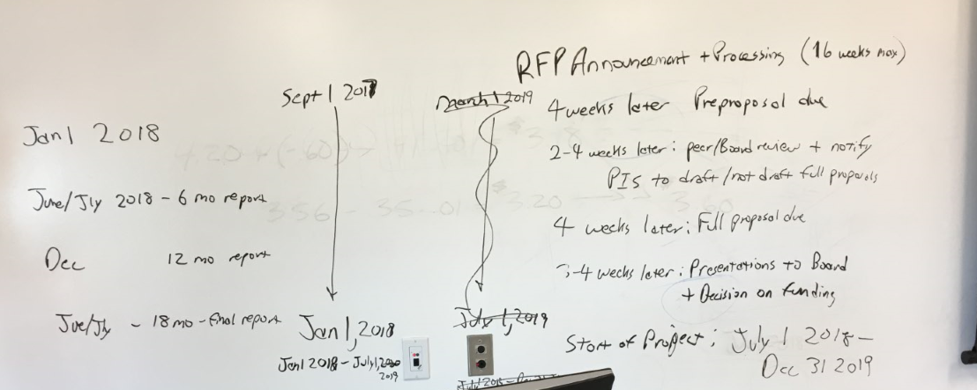

Decisions were also made on who would have access to preproposals and full proposals

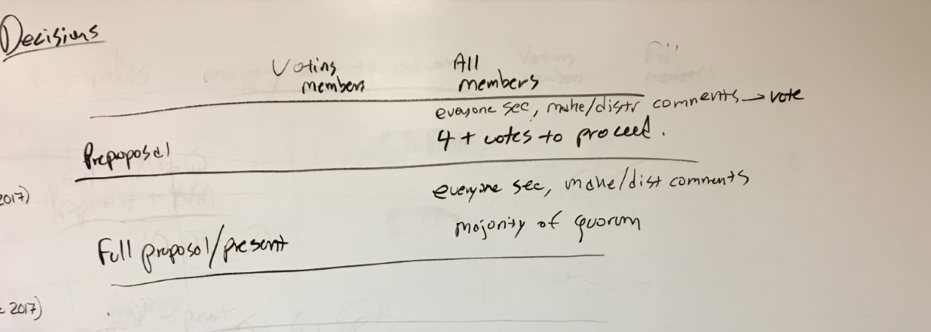

Discussion was held on reports that researchers who had proposals funded would provide a short oral and written report on annual progress. Researchers who received new proposals along with researchers asking for an extension of their proposals at the same meeting in December of 2018. An 18 month final written and oral presentation would be given in June/July of 2018, which would meet the state of South Dakota’s requirements.
Discussion was held on how decisions on proposals would be decided to be funded. A voting majority of 4 or more is needed for a preproposal to continue to a full proposal for vote.
Presentations were then given by researchers with a 10 minute presentation and an additional 5 minutes for questions.
Conversations on Proposals and Votes are below:
Rachel McDaniel- Vote to Fund did not carry. Vote was 4 yes to 4 no
The council has a concern with the lack of rotations included in the proposal. There was also a concern that the research would be at the mercy of Mother Nature when it comes to rainfall. The council suggests the following things for Dr. McDaniel to consider in presenting this proposal again in the future:
Consider irrigated/non irrigated sites
Consider different tillage practices (no till, conventional till, or reduced tillage)
Rotational differences may be a factor as well.
Budget would need to be modified to consider suggestions listed above.

Peter Kovacs- Vote to fund did not carry. Vote was 4 yes to 4 no
Budget justification needed more specifics. Title indicated that N recommendations would be Site Specific. The proposal presented to the council was more about re-doing baseline N recommendations that are outdated. A precision ag component should be included in the future if baseline recommendations are updated. The council suggests that Dr. Kovacs should submit another proposal that focusing more on updating baseline recommendations and then focus on site specific recommendations in the future.

Sandeep Kumar- Vote carried. Vote was 8 yes to 0 no
Proposal was straight forward, details were included. Council has positive comments around Dr. Kumar’s proposal using cover crops. The council questions whether the proposal is sustainable long term with adding wheat back into the rotation. A suggestion in the future is to perhaps not limit research to a wheat/corn/soy rotation.

David Karki- Vote carried. Vote was 5 yes to 3 no
Council had discussions on how impactful the work would really be. Discussion was held on the fact that General Mills is now a partner to SDSU in oat breeding research in South Dakota. The council agreed that the recommendations do need to be updated. In the future the council suggested that wheat may want to be included in the research Dr. Karki is conducted along with oats.
David Kringen- Vote did not carry. Vote was 0 yes and 8 no
Council agreed that the proposal put forward did not fit the description that the state of South Dakota put forward for uses of the money. The topic area was not specific enough
Shin-Yi Marzano-Mike Lehman Vote carried. Vote was 7 yes to 1 no
Crop Retention equals carbon and nutrient retention. Discussion was held on the fact that the ARS lab will close in Brookings if the current presidential budget passes as is. The council had a question of how does soil health increase nutrient uptake.
Srinivas Janaswamy -Vote carried. Vote was 6 yes to 2 no
The council agreed that the proposal put forward was an interesting concept. The question of how sustainable this proposal will be was raised. The council also questioned if this research is truly applicable in a field setting. The council questioned if cost estimates are accurate along with accuracy of 1 pound of polymers being needed for an acre. The council was also curious to know if the research would be applicable without a bio-reactor present on-site. A suggestion was made to have Dr. Janaswamy start on a small scale for year one and then costs and how much polymer can absorb can be more closely monitored.
Dr. Ruanbao Zhou- Vote did not carry. Vote was 3 yes to 5 no.
The council agreed that there may be more potential in the future for the type of research Dr. Zhou presented. The concern was if big companies have trouble with this process, how one researcher would be more successful, with such a highly variable process.

The meeting then shifted back to a business meeting. Discussion was held on setting the date for the next meeting. The council agreed on December 7, 2017 at the Cow Calf Teaching and Education Facility at South Dakota State University.
Discussion was then held on how much money was remaining after the current round of proposals was funded. $279,508 remains after funding.

Discussion was then held on officer term length.
Chair- Ryan Wolf will hold a 2 year term.
Vice Chair- Ryan Schuchhardt will hold a 3 year term
Treasurer- James Loken will hold a 2 year term
Secretary- Colin Nachtigal will hold a 3 year term
Other members term lengths are below.
Kevin Bachmeier- 1 year term
Al Miron- 1 year term
Richard Vasgaard- 2 year term
Richard Jenny- 3 year term
Bryan Jorgenson- 1 year term
Dana Loeske- 2 year term

Discussion then shifted to marking of the council. The council would like to have Lora Berg talk with the council for 30 minutes at the December meeting.
Discussion was then held on forming a sub-committee of council members to discuss what the council is looking for in proposals as far as topic.
A sub-committee was formed consisting of the following members:
James Loken
Richard Jenny
All Miron
Colin Nachtigal
Bryan Jorgenson
Bill Gibbons- will serve as an advisor to the committee.
Discussion was then had about the peer review process for proposals. Kathy Zander indicated she would check with Illinois on the process they use
Kevin Bachmeier made a motion to adjurn the meeting and the motion was seconded. The meeting was adjured.
Respectfully Submitted,
Melissa Vande Weerd- Assistant to the Director South Dakota Agricultural Experiment Station at SDSU

