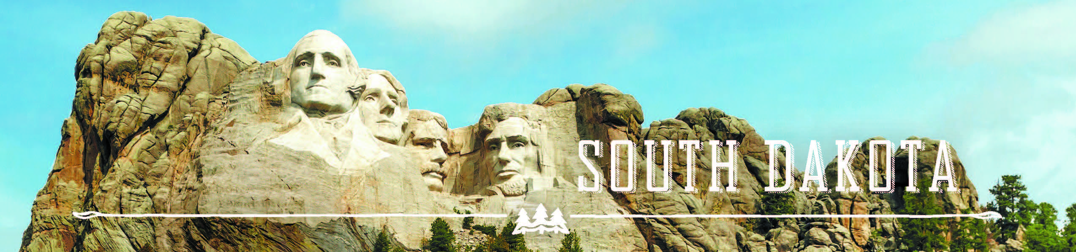

GOVERNOR’S TOURISM ADVISORY BOARD MEETING
Tuesday, April 11, 2017, 3:00 pm MST
Deadwood, South Dakota
Draft Agenda

3:00 pm Tour Sanford Lab Visitor Center
Billie Bierle
160 West Main Street
Lead, SD

4:30 pm Tour Deadwood Welcome Center
Lee Harstad
1 - 99 Siever Street
Deadwood, SD

5:00 pm Dinner on your own

GOVERNOR’S TOURISM ADVISORY BOARD MEETING
Wednesday, April 12, 2017, 8:30 am MST
Deadwood, South Dakota
Draft Agenda

SpringHill Suites
322 Main Street
Roosevelt 1 Room

8:30 am Call Meeting to Order, President Ted Hustead

8:35 am Tourism Board Member Reports

9:00 am Regional Director Reports
Jacquie Fuks, Southeast SD Tourism Association
Rosie Smith, Glacial Lakes and Prairies Tourism Association
Michelle Thomson, Black Hills and Badlands Tourism Association

9:15 am Welcome from Chuck Turbiville, Mayor of Deadwood

9:20 am Updates from Lee Harstad, Deadwood Chamber and Visitors Bureau

9:35 am Mount Rushmore National Memorial, Acting Chief of Interpretation and Education, Blaine Kortemeyer

9:50 am Jewel Cave National Memorial, Chief of Interpretation, Bradley Block

10:05 am Minuteman Missile National Historic Site, Superintendent Eric Leonard

10:20 am Wind Cave National Park, Acting Superintendent Steve Thede

10:35 am Badlands National Park, Chief of Resource Education, Christine Czazasty
10:45 am Custer State Park and Spearfish Canyon Project Updates, Matt Snyder, Custer State Park

11:00 am New Structure, New Teams, and Strategic Plan, Secretary Jim Hagen

11:10 am Global Marketing and Brand Strategy Update, Mike Gussiaas and Thad Friedeman, Tourism

11:30 am Social Media Update, Stephanie Palmer, Tourism

11:40 am Denver Travel Show and Pheasant Fest, Austin Kaus, Tourism

11:50 am Global Media and Public Relations Update, Katlyn Richter, Tourism

12:00 pm Working Lunch

12:10 am Industry Outreach and Development Update, Kirk Hulstein, Tourism

12:20 pm National Travel and Tourism Week, Natasha Bothun, Tourism

12:30 pm Updates on Global Travel and Trade, Cole Irwin, Tourism

12:40 pm VEP Program Updates, Mike Gussiaas, Tourism

1:00 pm Welcome Center Updates, Wanda Goodman and Nate Johnson, Tourism

1:10 pm Secretary‘s Recap, Secretary Jim Hagen

1:30 pm Meeting Adjourned

