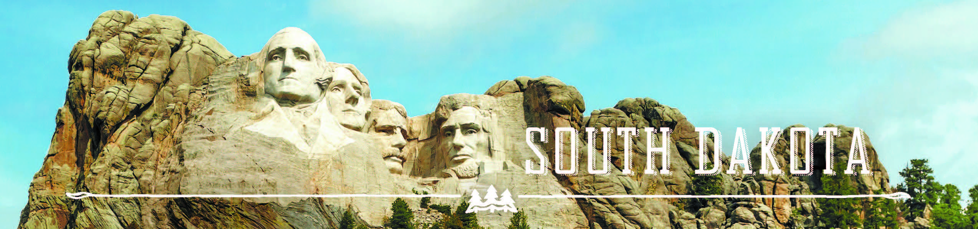

GOVERNOR’S TOURISM ADVISORY BOARD MEETING
Tuesday, April 11, 2017, 3:00 pm MST
Deadwood, South Dakota

3:00 pm Tour Sanford Lab Visitor Center
Billie Bierle
160 West Main Street
Lead, SD

4:30 pm Tour Deadwood Welcome Center
Lee Harstad
1 - 99 Siever Street
Deadwood, SD

5:00 pm Dinner on your own

GOVERNOR’S TOURISM ADVISORY BOARD MEETING
Wednesday, April 12, 2017, 8:30 am MST
Deadwood, South Dakota

SpringHill Suites
322 Main Street
Roosevelt 1 Room

8:30 am Call Meeting to Order, President Ted Hustead

8:35 am Tourism Board Member Reports

9:00 am Regional Director Reports
Jacquie Fuks, Southeast SD Tourism Association
Rosie Smith, Glacial Lakes and Prairies Tourism Association
Michelle Thomson, Black Hills and Badlands Tourism Association

9:15 am Welcome from Chuck Turbiville, Mayor of Deadwood

9:20 am Updates from Lee Harstad, Deadwood Chamber and Visitors Bureau

9:35 am Black Hills Central Reservations / South Dakota Central Reservations, Susan Johnson

9:50 am Mount Rushmore National Memorial, Acting Chief of Interpretation and Education, Blaine Kortemeyer

10:05 am Jewel Cave National Memorial, Chief of Interpretation, Bradley Block

10:20 am Minuteman Missile National Historic Site, Superintendent, Eric Leonard

10:35 am Wind Cave National Park, Chief of Interpretation, Tom Farrell

10:50 am Badlands National Park, Chief of Resource Education, Christine Czazasty

11:05 am Custer State Park and Spearfish Canyon Project Updates, Matt Snyder, Custer State Park

11:20 am New Structure, New Teams, and Strategic Plan, Secretary Jim Hagen

11:30 am Global Media and Public Relations Update, Katlyn Richter, Tourism

11:40 am Industry Outreach and Development Update, Kirk Hulstein, Tourism

11:50 am National Travel and Tourism Week, Natasha Bothun, Tourism

12:00 pm Working Lunch

12:10 pm Global Marketing and Brand Strategy Update, Mike Gussiaas and Thad Friedeman, Tourism

12:30 pm Social Media Update, Stephanie Palmer, Tourism

12:40 pm Denver Travel Show and Pheasant Fest, Austin Kaus, Tourism

12:50 pm Updates on Global Travel and Trade, Cole Irwin, Tourism

1:00 pm VEP Program Updates, Mike Gussiaas, Tourism

1:20 pm Welcome Center Updates, Wanda Goodman and Nate Johnson, Tourism

1:30 pm Secretary‘s Recap, Secretary Jim Hagen

1:50 pm Meeting Adjourned

