Department of Executive Management
Bureau of Finance and Management
500 East Capitol Ave. Pierre, South Dakota 57501-5070 Voice: (605) 773-3411 Fax: (605) 773-4711

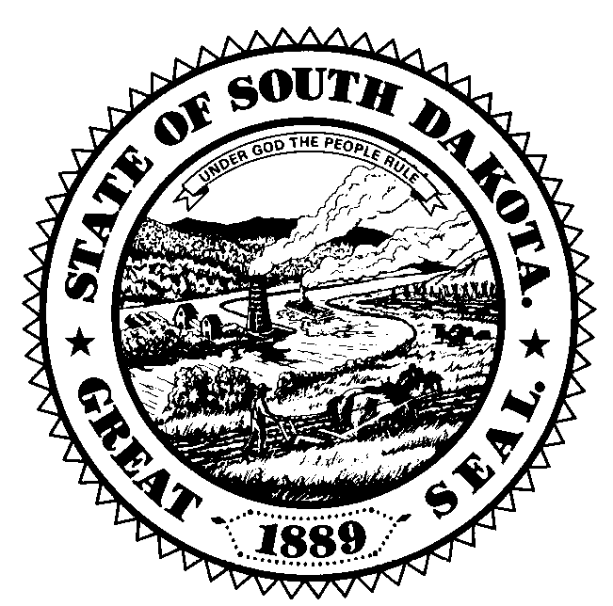

Governor’s Council of Economic Advisors Meeting
May 17, 2018

South Dakota Investment Council Office
4009 West 49th Street, 3rd Floor
Sioux Falls, SD 57106

11:00 PM –11:30 PM
South Dakota Investment Council Update

- South Dakota Investment Council staff will provide an overview of the activities of the SDIC

11:30 PM –1:30 PM
Update on most recent US economic forecast/SD economic trends

- Dr. Ralph Brown will present the most recent IHS Economics forecast for the United States economy as well as recent trends in the South Dakota economy including trends in employment, income and various other economic indicators specific to South Dakota.

- Council discussion on specific regional areas of the state and how those regions are performing economically, including any possible positive or negative developments that could impact the state economy.

- Council discussion on agriculture, tourism, manufacturing, financial services as well as other sectors that have a large presence in the state and how those specific sectors are performing or are expected to perform over 2018-2020.

1:30 PM – 3:00 PM
Overview of SD economic forecast and recent tax collection trends

- Jim Terwilliger will present the most recent SD specific forecast for specific SD economic indicators from IHS Economics.

- Jim Terwilliger will present recent general fund revenue collection trends for major revenue sources that populate the state general fund and how those collection trends compare to the most recent budgeted levels and historical growth rates.

- General council discussion on the economic and revenue trends and the outlook for 2018-2020, including possible positive and negative risks that are currently present in the economic outlook for South Dakota.

3:00 PM - Adjourn

