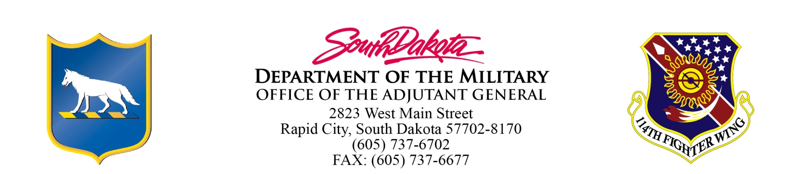
AGENDA
Board of Military Affairs Meeting
June 13-14, 2018
Rapid City, SD

Wednesday, June 13th

Board Members travel via their privately owned vehicles to Rapid City, SD

2:45 pm Arrive Camp Rapid (reserved parking provided)
(Greeted by TAG’s Executive Officer – Major Mitch Nachtigall)

3:00 pm Meeting convenes - AGO Conference Room

- Welcome and Introductions
- Review/Approve Minutes of the February 2, 2017 Meeting
- Sign travel vouchers

3:15 pm Golden Coyote Exercise Briefing

4:00 pm Break

4:30 pm National Guard Update by MG Reisch

5:00 pm Travel to motel (check into rooms)

6:30 pm Dinner - Shooters Wood Fire Grill, 2424 W. Main St, Rapid City, SD

-------------

Thursday, June 14th

7:30 am Meeting reconvenes - AGO Conference Room (coffee, open discussion)

8:00 am Depart for Golden Coyote sites (ground & air transportation provided)

1:00 pm Meeting Adjourns (sign travel vouchers before departing)

Individuals needing assistance pursuant to the Americans with Disabilities Act should contact Steve Harding at the South Dakota Department of the Military (605-773-5341) 48 hours before convening to make any necessary arrangements.

