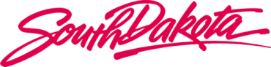

Ellsworth Development Authority
________________________________

AGENDA

Board of Directors Meeting

13 June 2018, Wednesday, 10 am Mountain

14 Saint Joseph Street, Suite 200, Rapid City, SD 57709
2nd Floor Bank Conference Room

Dial-In Instructions – Participant
Dial: 1 866-939-8416 Password: 1594130

- Welcome - Call to Order (10 am)

a. Roll Call
b. Conflict of Interest Disclosure / Request for Waiver and Roll Call – Action Item

- Pursuant to SL 3-23-1 and absent a waiver, no elected or appointed member of a state authority, board, or commission may have an interest in or derive a direct benefit from any contract(s).

- Does any SDEDA BOD member have an interest in or derive a direct benefit from any existing or future contract(s)?

- Are there any requests for waivers?

- Roll Call

c. Approval of Agenda - Action Item
d. Approval of Minutes from 21 February 2018 - Board Meeting – Action Item

2. Business Updates:

- Old Business
- New Business
(1) Resolution 18-06: Consider resolution approving the SDEDA FY2019 Budget - Action Item

3. Adjournment

